Lecture 9:

Understanding and Visualizing Convolutional Neural Networks



Fei-Fei Li & Andrej Karpathy & Justin Johnson Lecture 9 1 3 Feb 2016

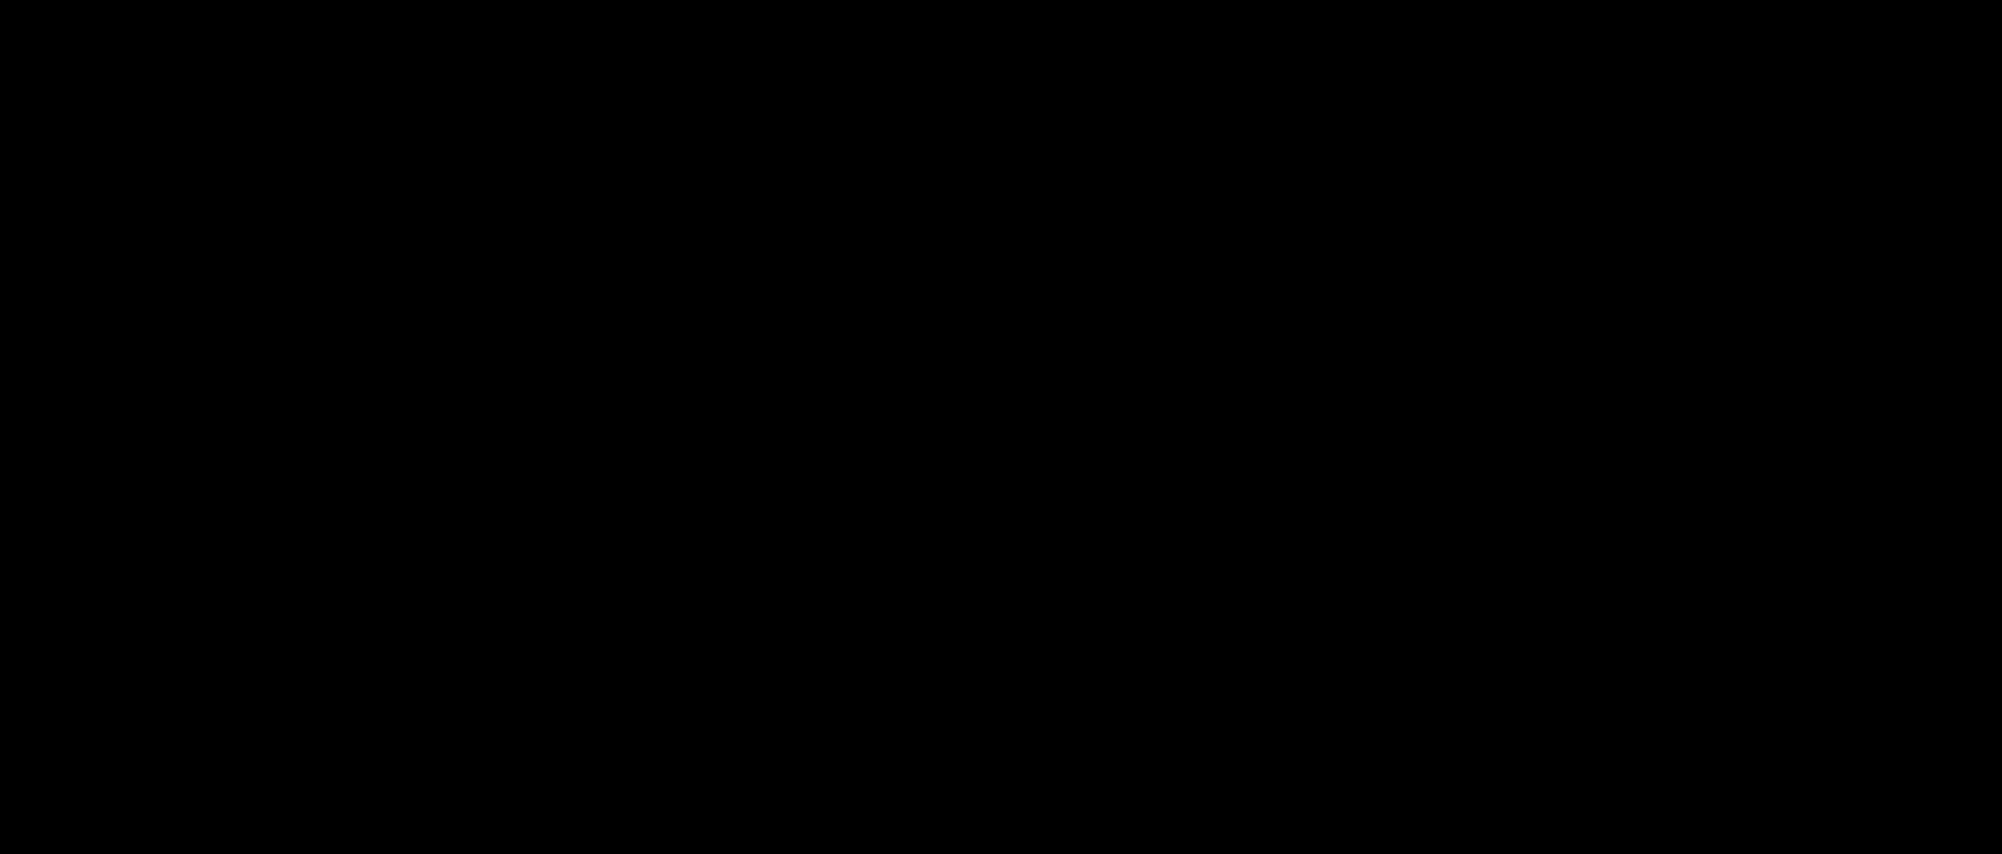Administrative

* A1 is graded. We’ll send out grades tonight (or so)
* A2 is due Feb 5 (this Friday!): **submit in Assignments tab** on CourseWork (not Dropbox)
* Midterm is Feb 10 (next Wednesday)
* Oh and pretrained ResNets were released today

(152-layer ILSVRC 2015 winning ConvNets)

<https://github.com/KaimingHe/deep-residual-networks>



Fei-Fei Li & Andrej Karpathy & Justin Johnson Lecture 9 2 3 Feb 2016

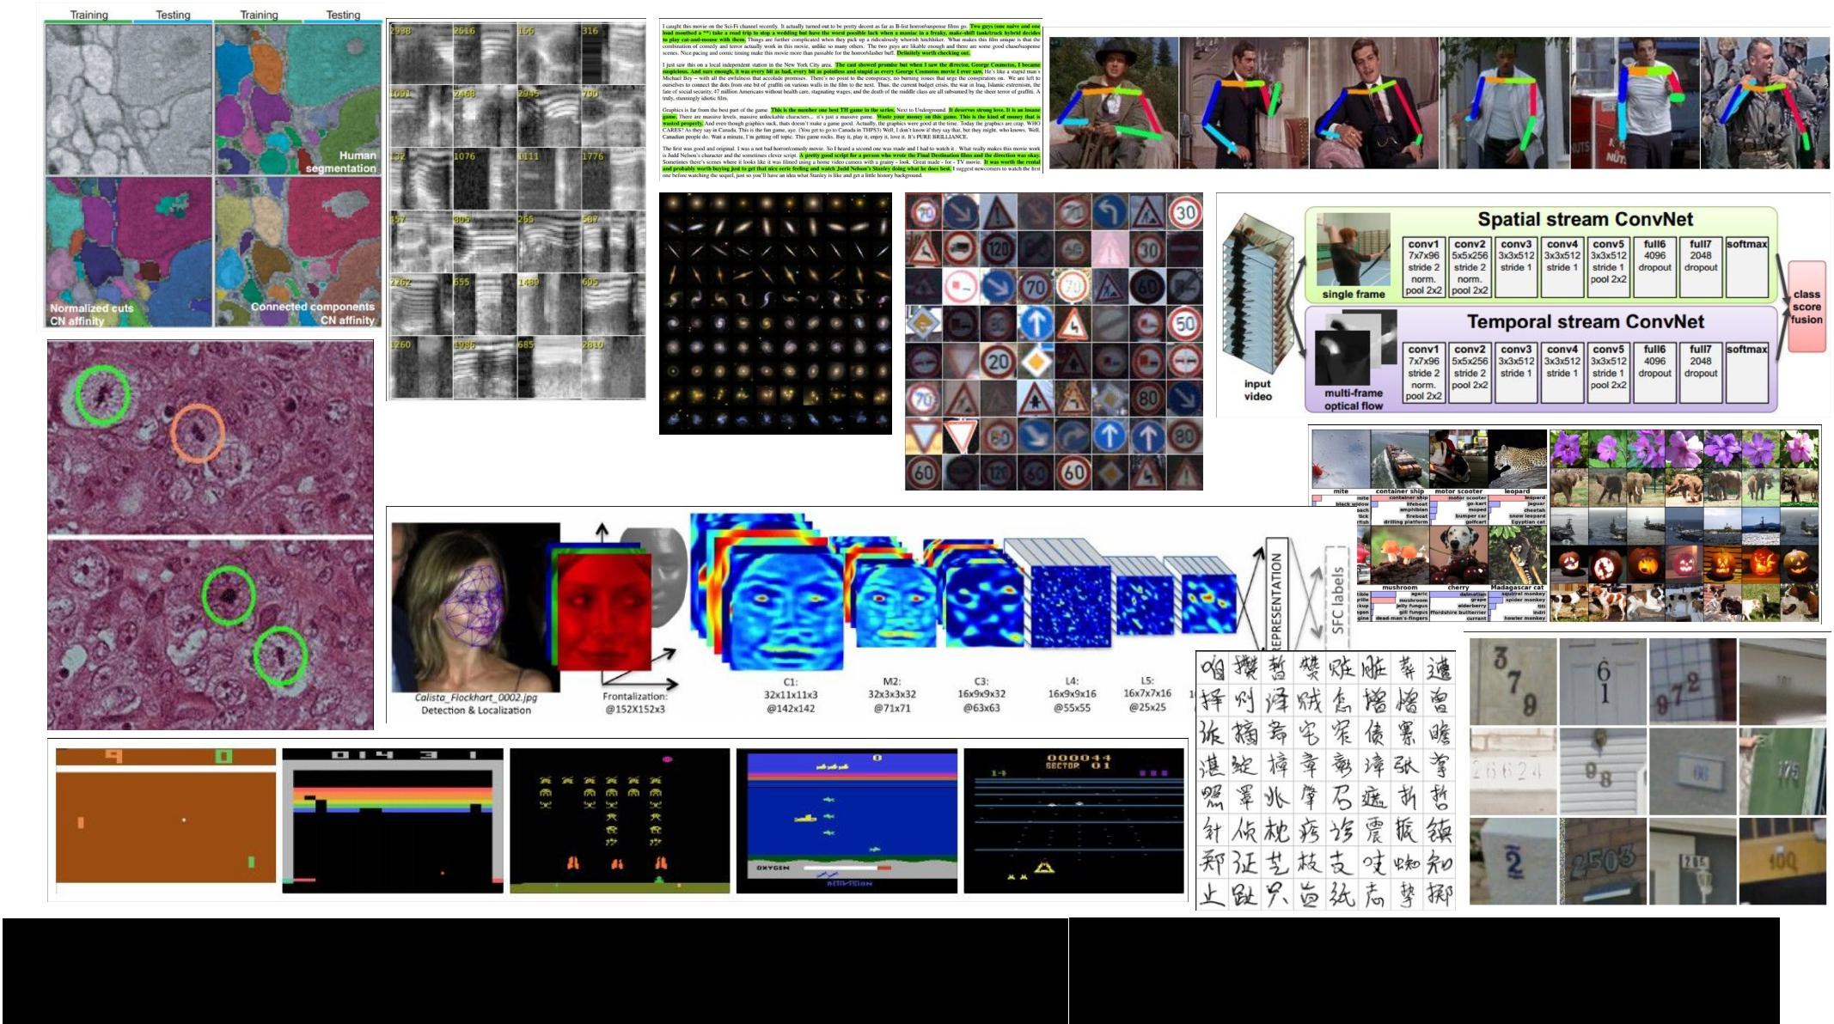

|  |  |  |
| --- | --- | --- |
| Fei-Fei Li & Andrej Karpathy & Justin Johnson | Lecture 9 3 | 3 Feb 2016 |
|  |  |  |

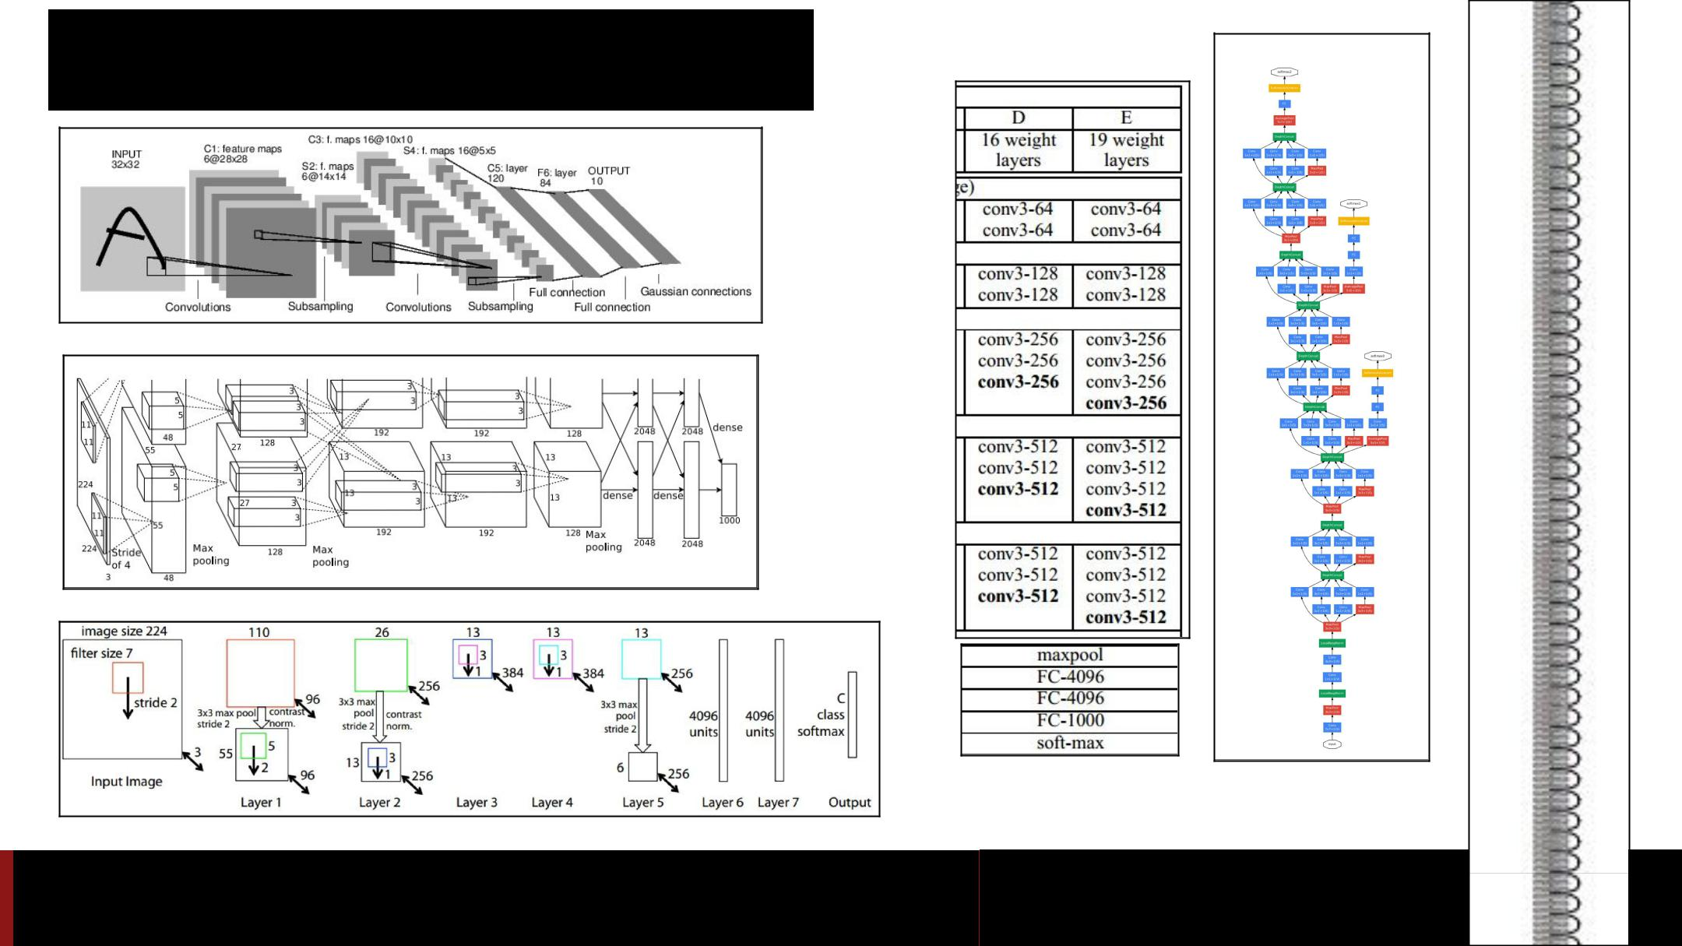ConvNets

Fei-Fei Li & Andrej Karpathy & Justin Johnson Lecture 9 4 3

Computer Vision Tasks

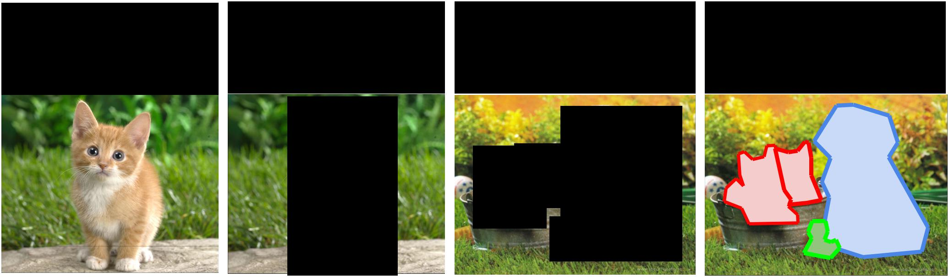

|  |  |  |  |  |  |  |  |  |  |  |  |  |  |  |
| --- | --- | --- | --- | --- | --- | --- | --- | --- | --- | --- | --- | --- | --- | --- |
| **Classification** | **Classification** | | | | | **Object Detection** | | | | | | | **Instance** |  |
| **+ Localization** | | | | | **Segmentation** |  |
|  |  |  |  |  |  |  |  |  |
|  |  |  |  |  |  |  |  |  |  |  |  |  |  |  |
|  |  |  |  |  |  |  |  |  |  |  |  |  |  |  |
|  |  |  |  |  |  |  |  |  |  |  |  |  |  |  |
|  |  |  |  |  |  |  |  |  |  |  |  |  |  |  |
|  |  |  |  |  |  |  |  |  |  |  |  |  |  |  |
|  |  |  |  |  |  |  |  |  |  |  |  |  |  |  |
|  |  |  |  |  |  |  |  |  |  |  |  |  |  |  |
|  |  |  |  |  |  |  |  |  |  |  |  |  |  |  |
|  |  |  |  |  |  |  |  |  |  |  |  |  |  |  |
|  |  |  |  |  |  |  |  |  |  |  |  |  |  |  |



CAT CAT CAT, DOG, DUCK CAT, DOG, DUCK



Single object Multiple objects

Fei-Fei Li & Andrej Karpathy & Justin Johnson Lecture 9 5 3 Feb 2016

Understanding ConvNets

* Visualize patches that maximally activate neurons
* Visualize the weights
* Visualize the representation space (e.g. with t-SNE)
* Occlusion experiments
* Human experiment comparisons
* Deconv approaches (single backward pass)
* Optimization over image approaches (optimization)



Fei-Fei Li & Andrej Karpathy & Justin Johnson Lecture 9 6 3 Feb 2016

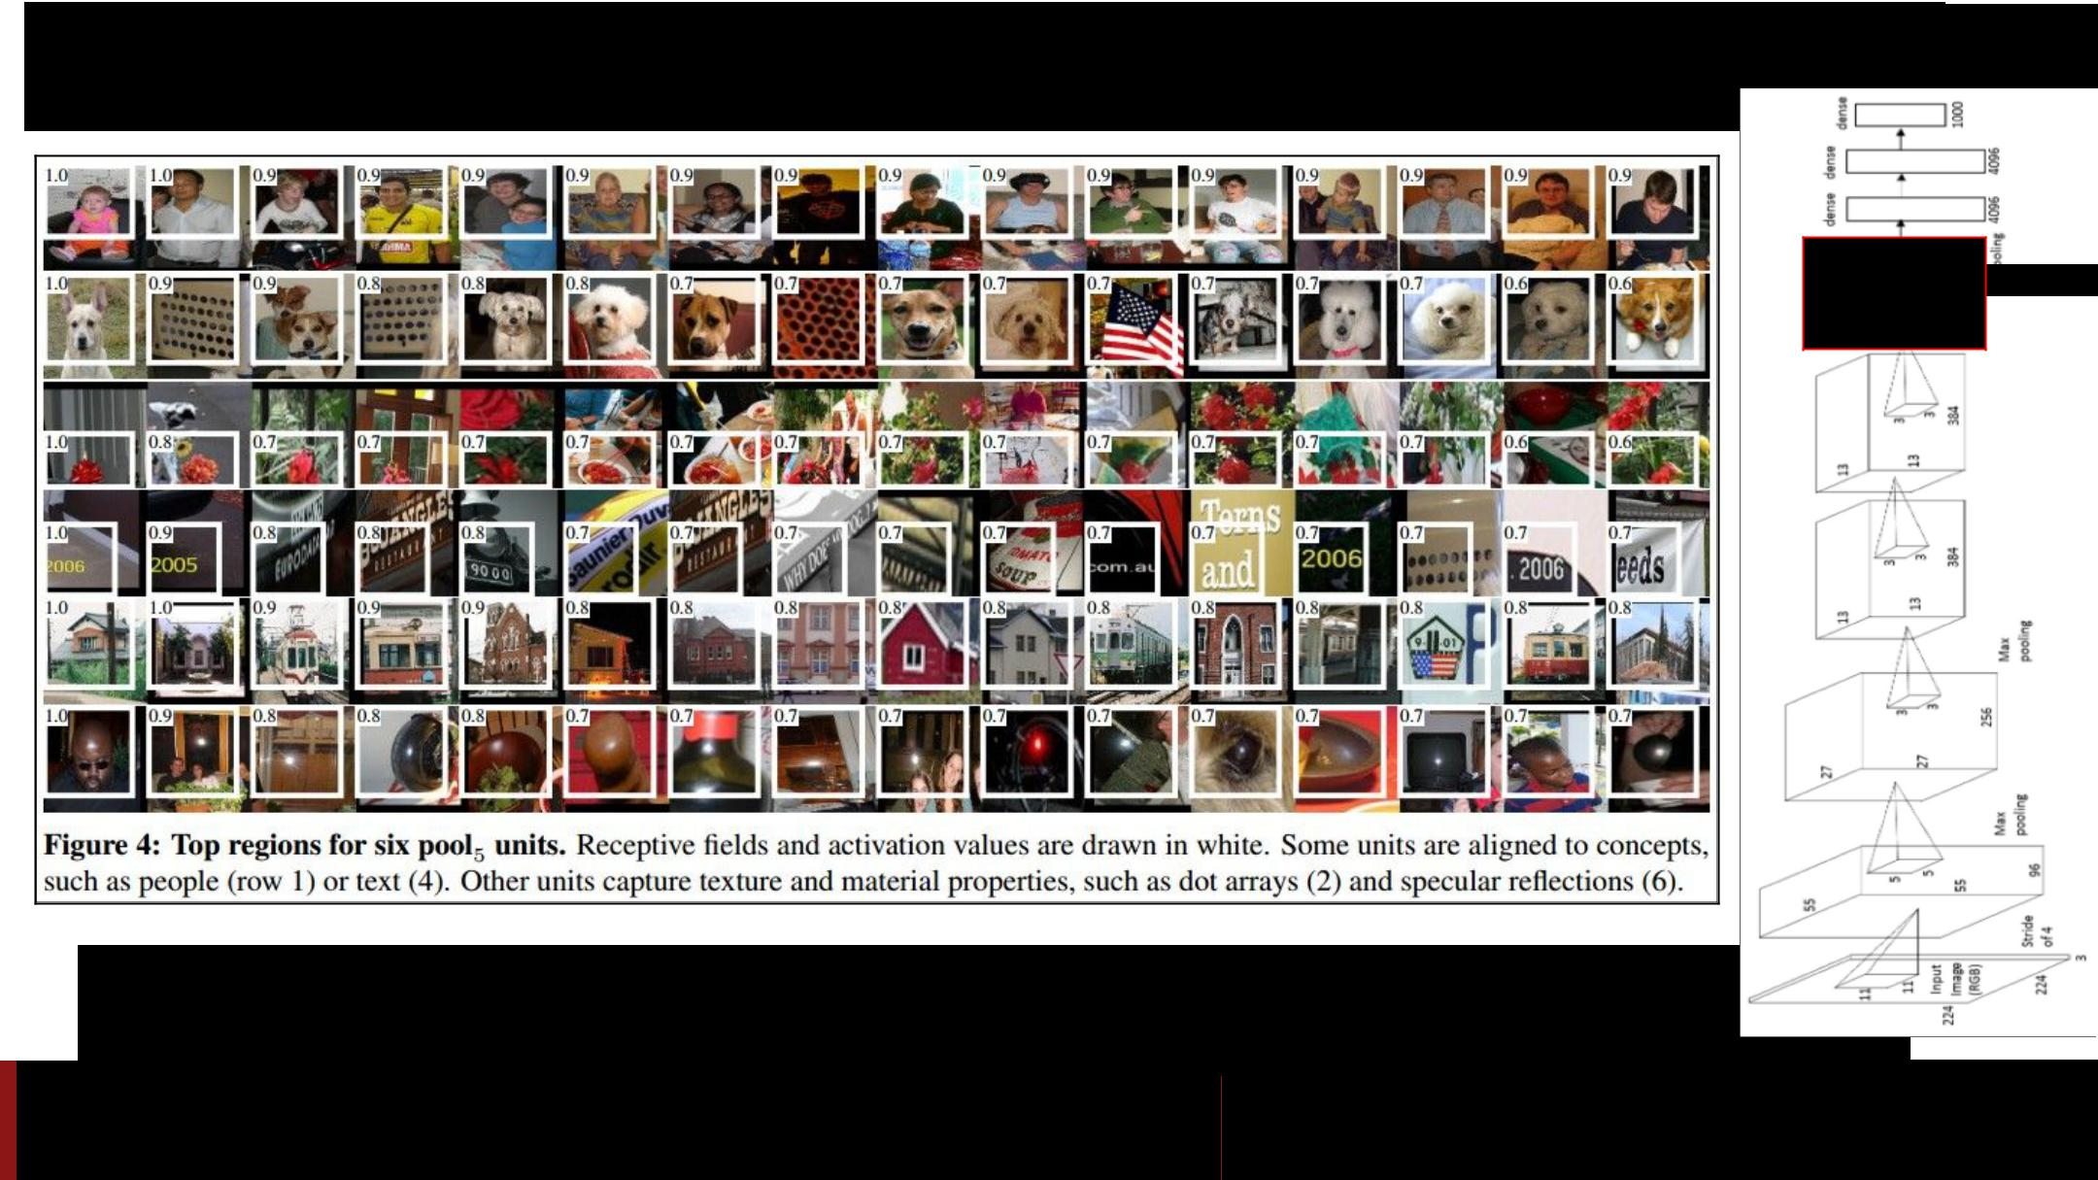Visualize patches that maximally activate neurons

*Rich feature hierarchies for accurate object detection and semantic segmentation [Girshick, Donahue, Darrell, Malik]*

one-stream AlexNet

pool5

Fei-Fei Li & Andrej Karpathy & Justin Johnson Lecture 9 7 3 Feb 2016

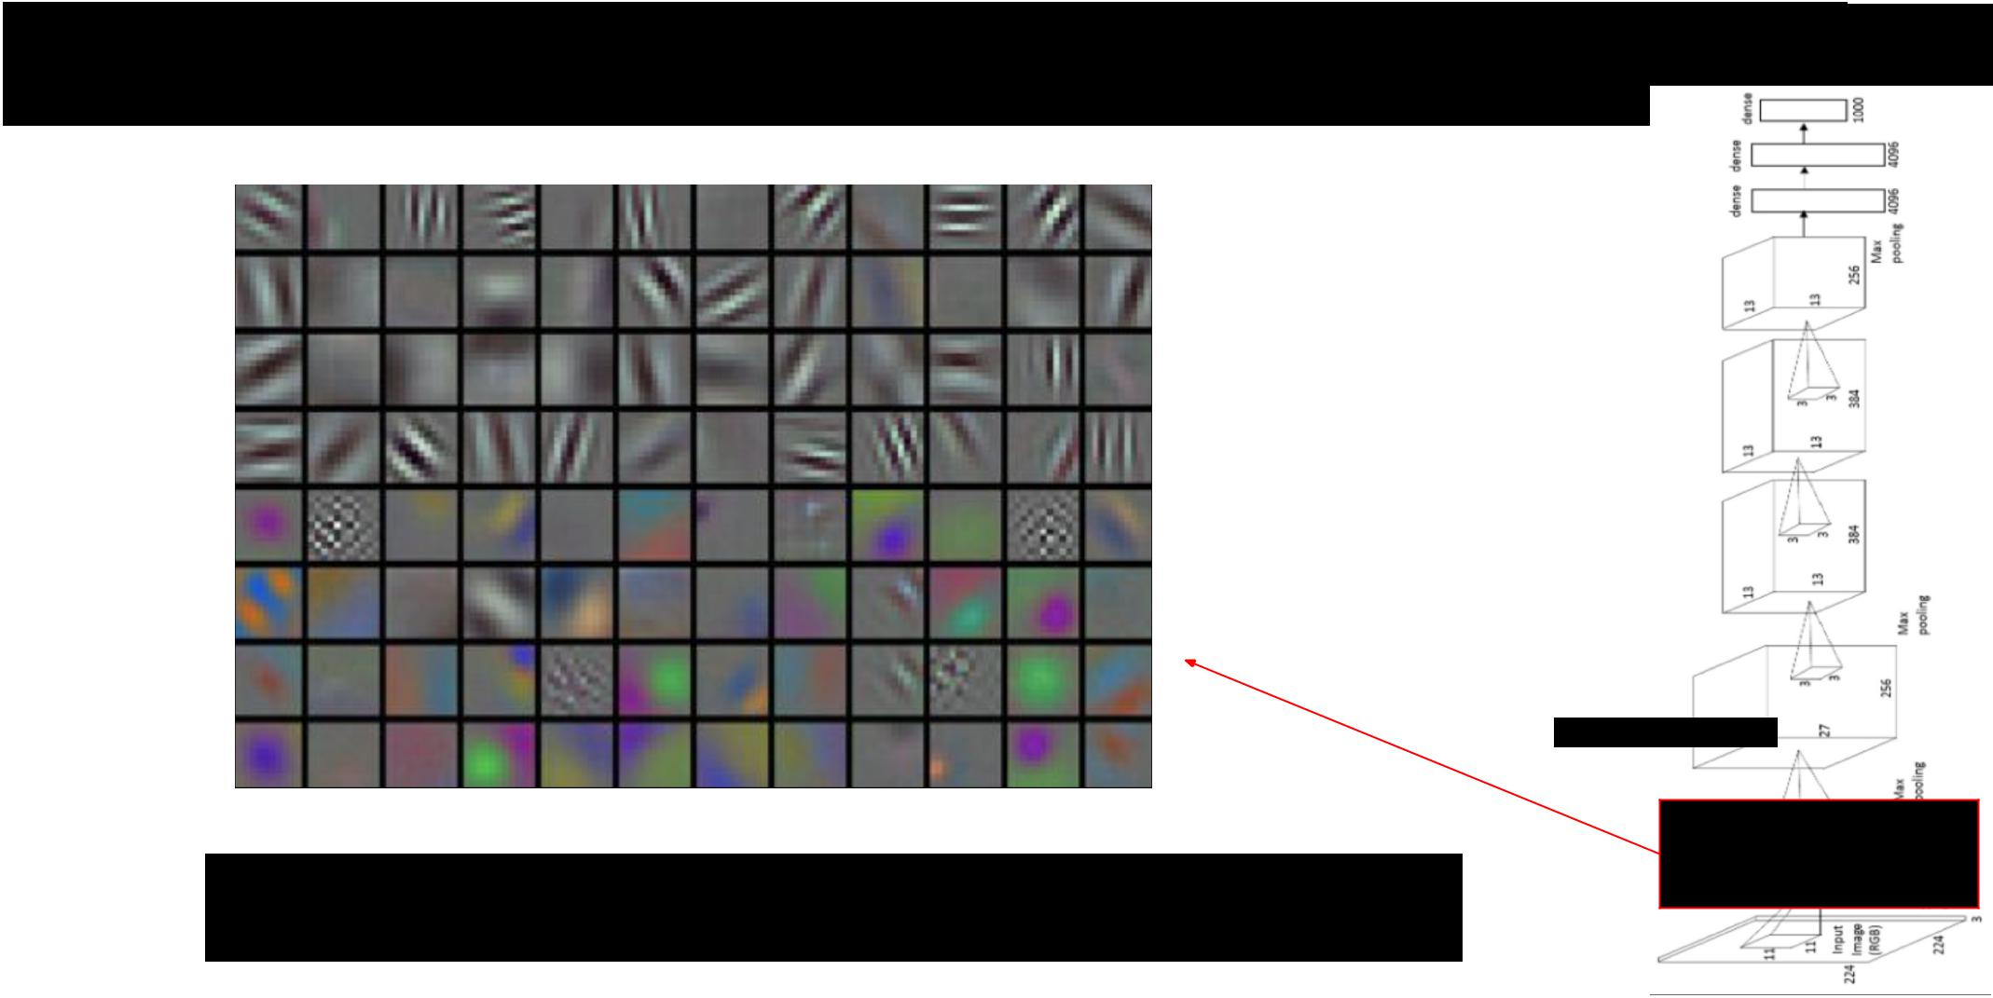Visualize the filters/kernels (raw weights)

one-stream AlexNet

conv1

only interpretable on the first layer :(



Fei-Fei Li & Andrej Karpathy & Justin Johnson Lecture 9 8 3 Feb 2016

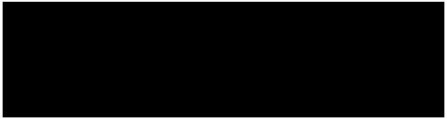

Visualize the filters/kernels (raw weights)

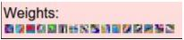

you can still do it for higher layers, it’s just not that interesting

(these are taken from ConvNetJS CIFAR-10 demo)



layer 1 weights

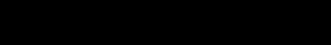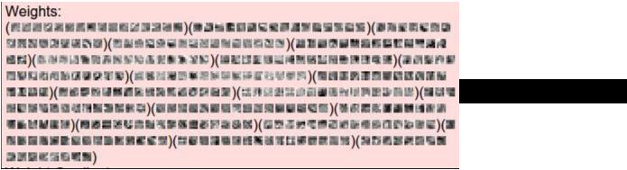

layer 2 weights

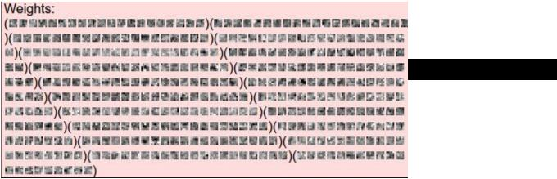

layer 3 weights

|  |  |  |
| --- | --- | --- |
| Fei-Fei Li & Andrej Karpathy & Justin Johnson | Lecture 9 9 | 3 Feb 2016 |
|  |  |  |

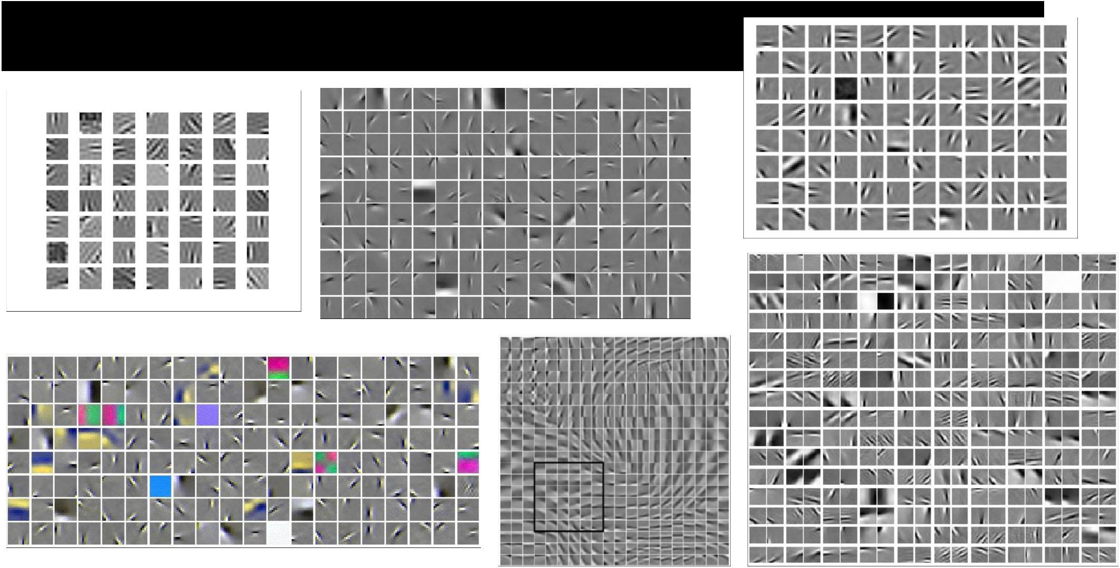The gabor-like filters fatigue



Fei-Fei Li & Andrej Karpathy & Justin Johnson Lecture 9 10 3 Feb 2016

**Visualizing the representation**

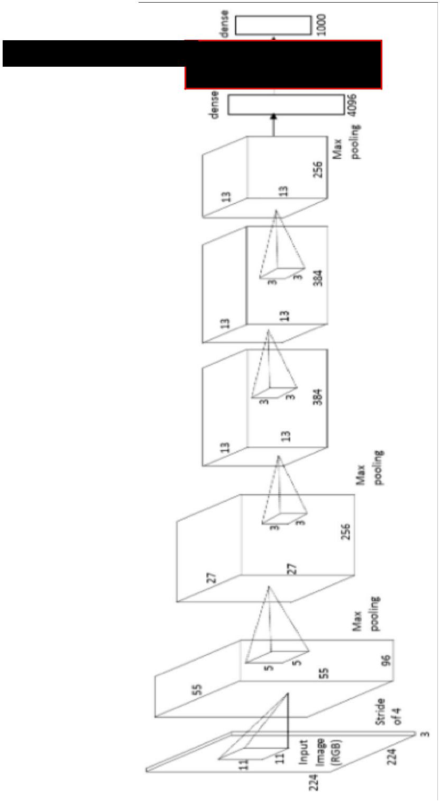

fc7 layer

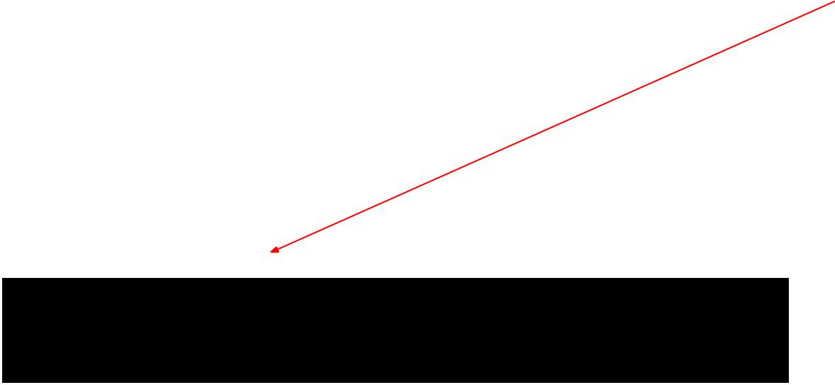

4096-dimensional “code” for an image (layer immediately before the classifier)

can collect the code for many images



Fei-Fei Li & Andrej Karpathy & Justin Johnson Lecture 9 11 3 Feb 2016

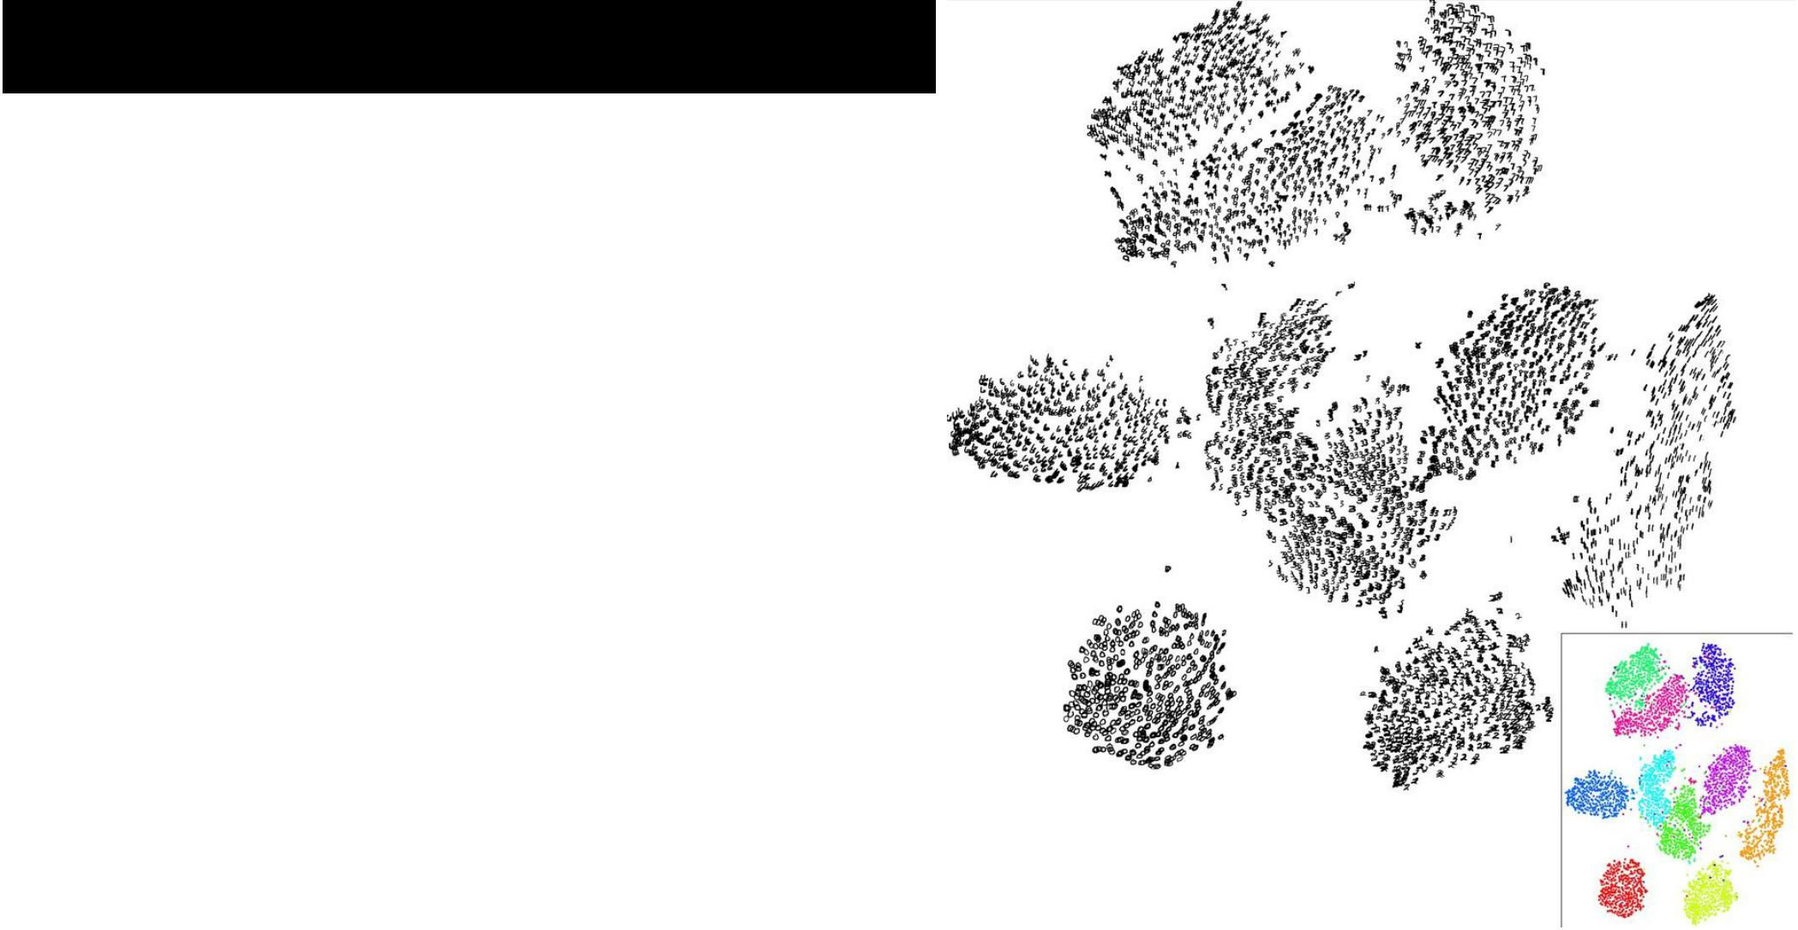

**Visualizing the representation**

t-SNE visualization

*[van der Maaten & Hinton]*

Embed high-dimensional points so that locally, pairwise distances are conserved

i.e. similar things end up in similar places. dissimilar things end up wherever

**Right**: Example embedding of MNIST digits(0-9) in 2D



|  |  |  |
| --- | --- | --- |
| Fei-Fei Li & Andrej Karpathy & Justin Johnson | Lecture 9 12 | 3 Feb 2016 |
|  |  |  |

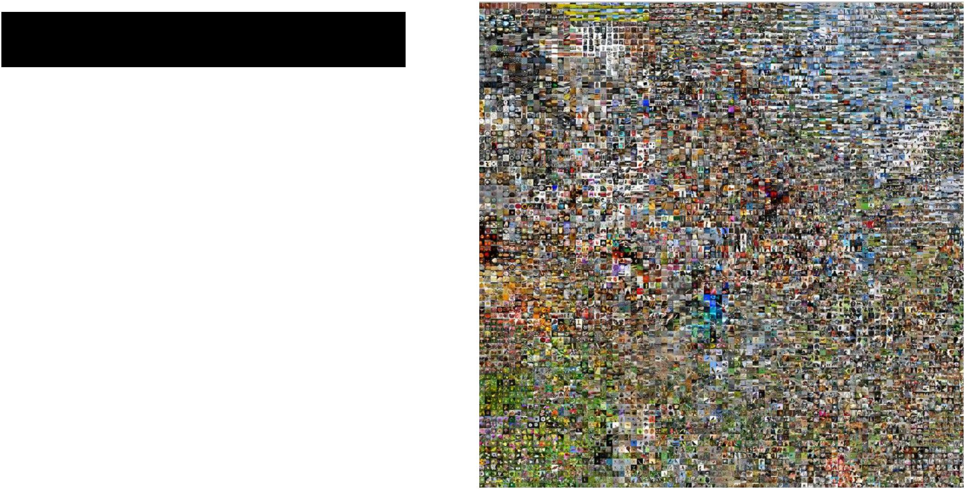t-SNE visualization:

two images are placed nearby if their CNN codes are close. See more:

[http://cs.stanford.](http://cs.stanford.edu/people/karpathy/cnnembed/) [edu/people/karpathy/cnnembed/](http://cs.stanford.edu/people/karpathy/cnnembed/)



Fei-Fei Li & Andrej Karpathy & Justin Johnson Lecture 9 13 3 Feb 2016

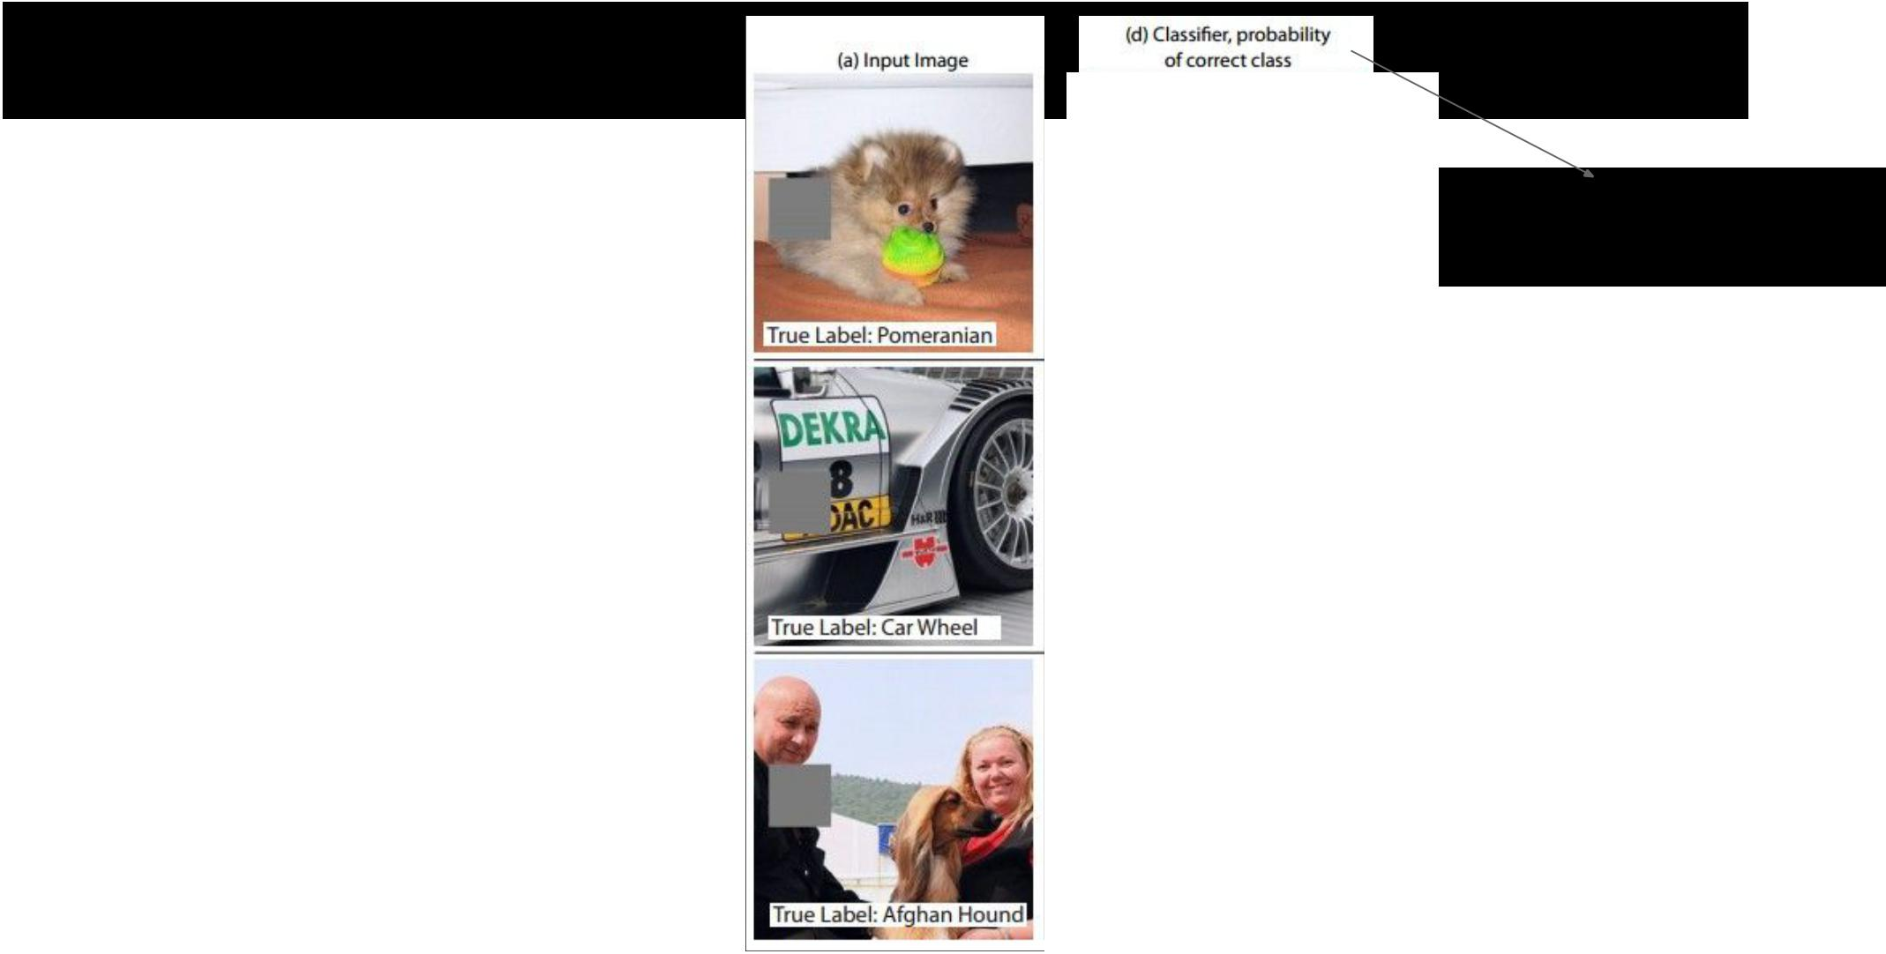Occlusion experiments

[Zeiler & Fergus 2013]

(as a function of the

position of the

square of zeros in

the original image)



Fei-Fei Li & Andrej Karpathy & Justin Johnson Lecture 9 14 3 Feb 2016

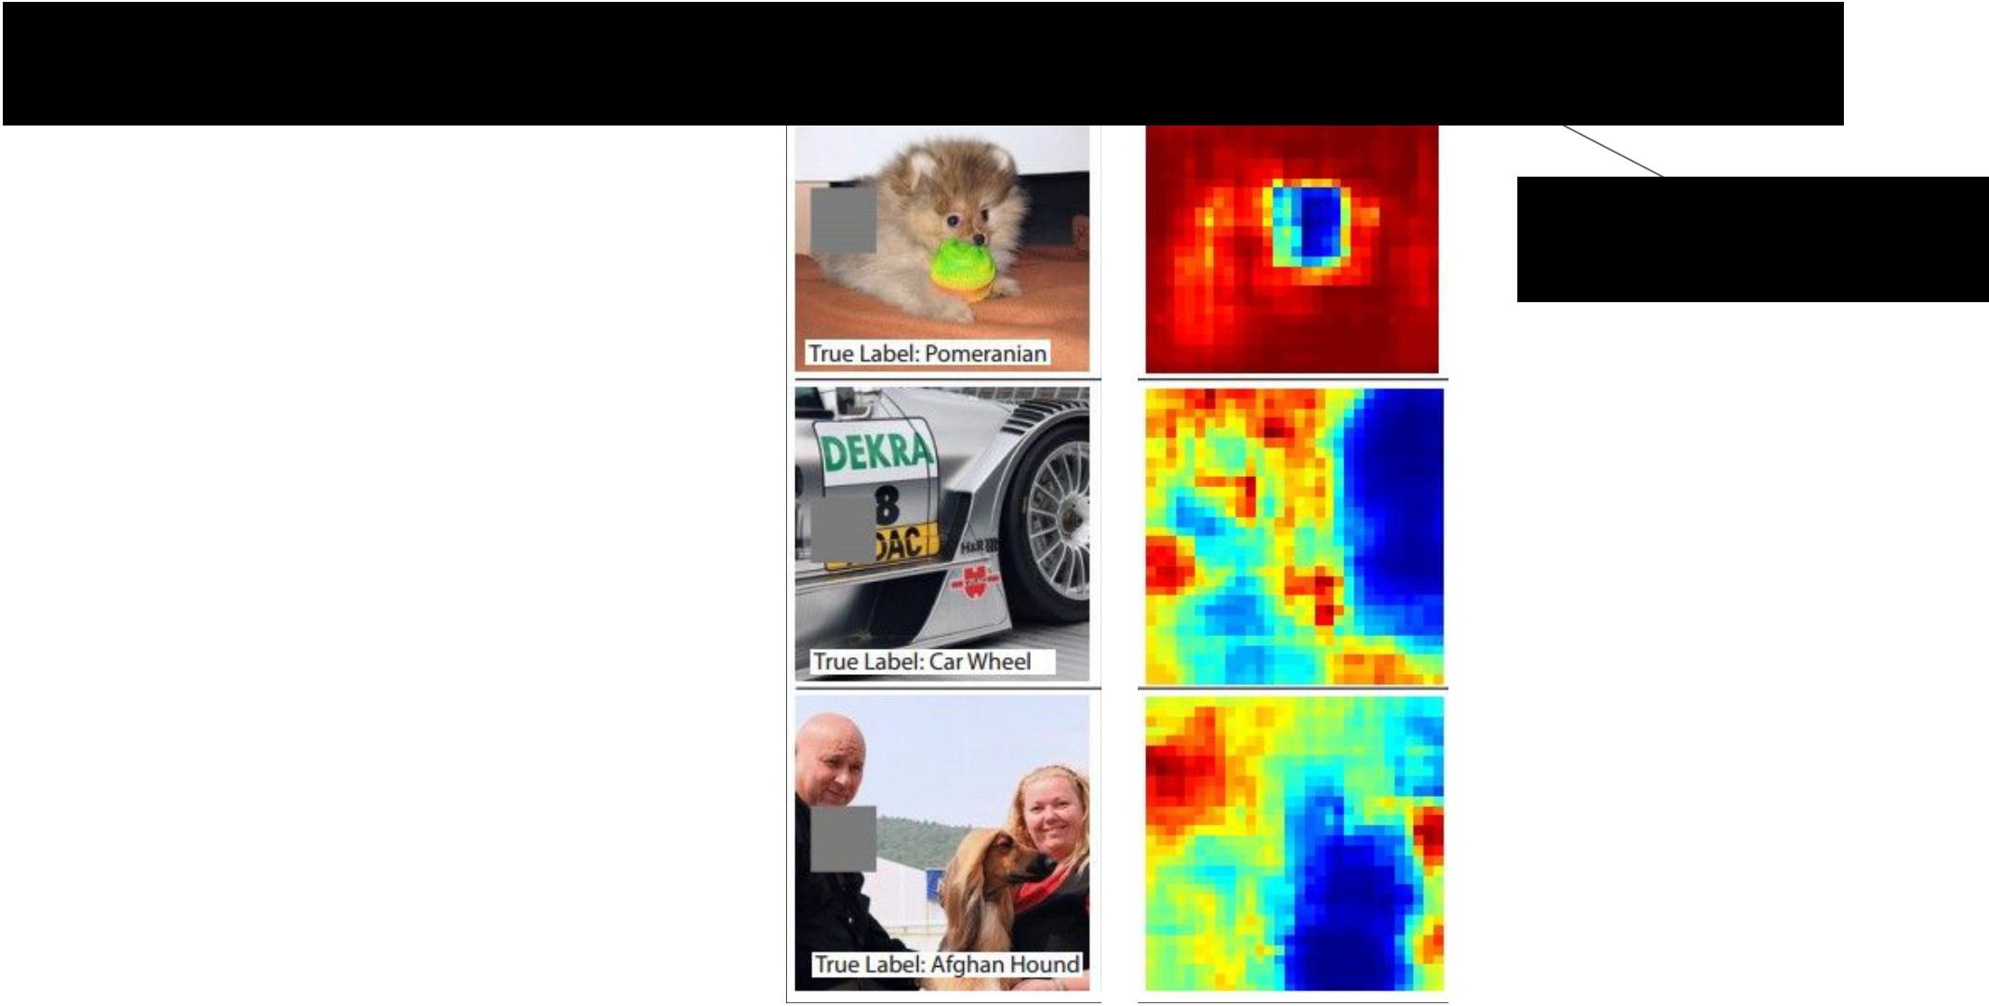Occlusion experiments

[Zeiler & Fergus 2013]

(as a function of the

position of the

square of zeros in

the original image)



Fei-Fei Li & Andrej Karpathy & Justin Johnson Lecture 9 15 3 Feb 2016

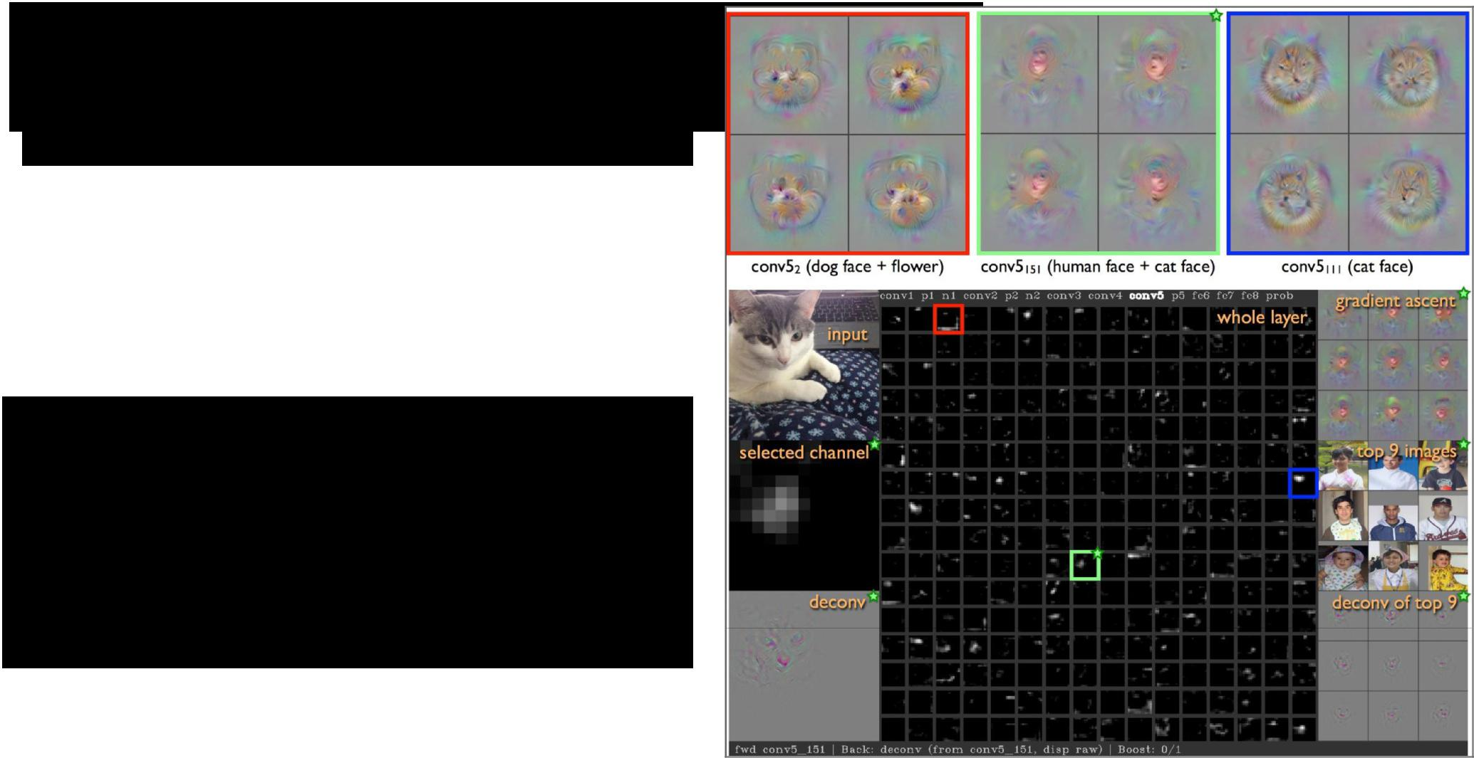Visualizing Activations

<http://yosinski.com/deepvis>

YouTube video

<https://www.youtube.com/watch?v=AgkfIQ4IGaM>

(4min)



Fei-Fei Li & Andrej Karpathy & Justin Johnson Lecture 9 16 3 Feb 2016

Deconv approaches

1. Feed image into net
   1. how can we compute the gradient of any arbitrary neuron in the network w.r.t. the image?

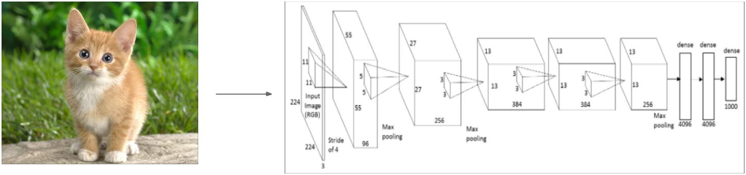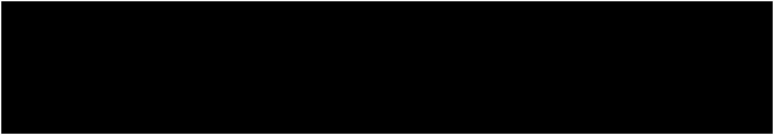

Fei-Fei Li & Andrej Karpathy & Justin Johnson Lecture 9 17 3 Feb 2016

Deconv approaches

1. Feed image into net

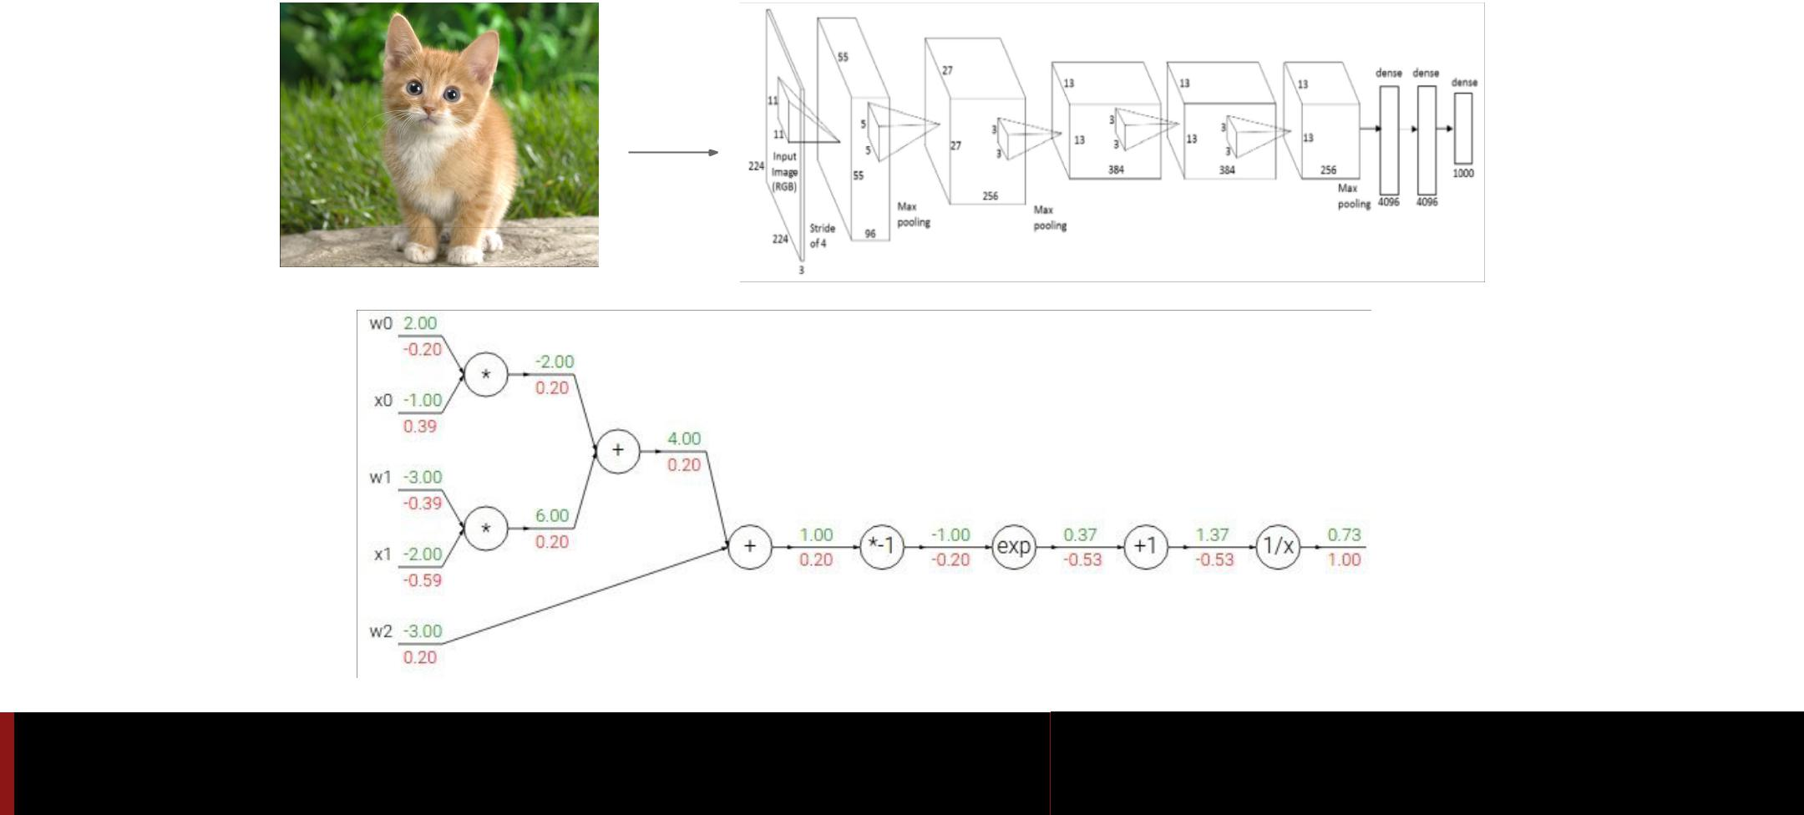

Fei-Fei Li & Andrej Karpathy & Justin Johnson Lecture 9 18 3 Feb 2016

Deconv approaches

1. Feed image into net

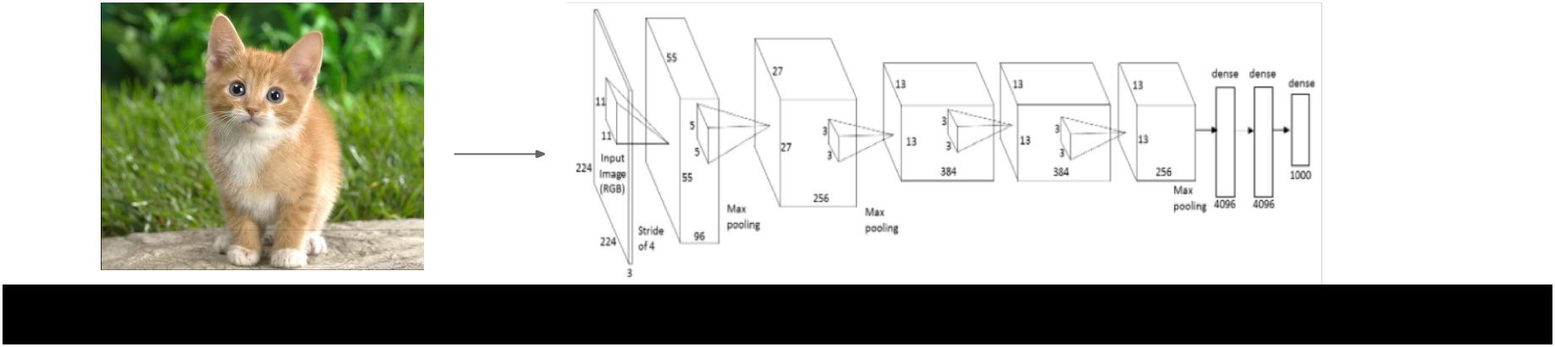

1. Pick a layer, set the gradient there to be all zero except for one 1 for some neuron of interest
2. Backprop to image:



Fei-Fei Li & Andrej Karpathy & Justin Johnson Lecture 9 19 3 Feb 2016

**“Guided**

**backpropagation:”** instead



Deconv approaches

1. Feed image into net



2. Pick a layer, set the gradient there to be all zero except for one 1 for

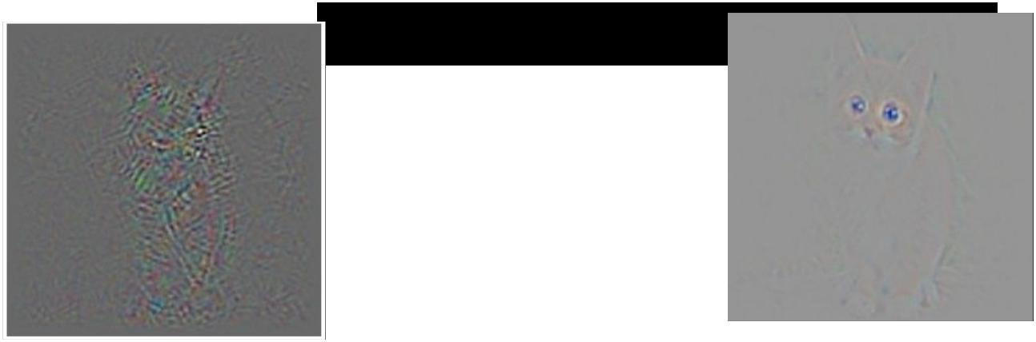

some neuron of interest

3. Backprop to image:



Fei-Fei Li & Andrej Karpathy & Justin Johnson Lecture 9 20 3 Feb 2016

Deconv approaches

*[Visualizing and Understanding Convolutional Networks, Zeiler and Fergus 2013]*

*[Deep Inside Convolutional Networks: Visualising Image Classification Models and Saliency Maps, Simonyan et al., 2014]*

*[Striving for Simplicity: The all convolutional net, Springenberg, Dosovitskiy, et al., 2015]*

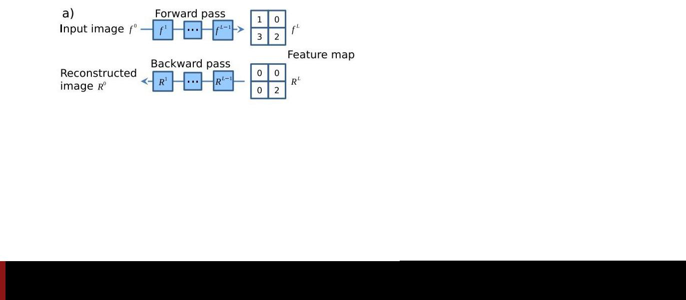

Fei-Fei Li & Andrej Karpathy & Justin Johnson Lecture 9 21 3 Feb 2016

Deconv approaches

*[Visualizing and Understanding Convolutional Networks, Zeiler and Fergus 2013]*

*[Deep Inside Convolutional Networks: Visualising Image Classification Models and Saliency Maps, Simonyan et al., 2014]*

*[Striving for Simplicity: The all convolutional net, Springenberg, Dosovitskiy, et al., 2015]*

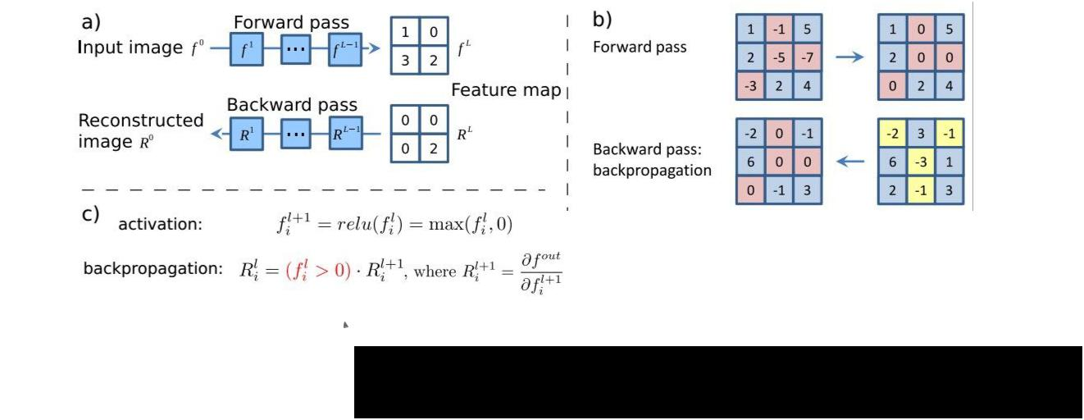

 Backward pass for a ReLU (will be changed in Guided Backprop)



Fei-Fei Li & Andrej Karpathy & Justin Johnson Lecture 9 22 3 Feb 2016

Deconv approaches

*[Visualizing and Understanding Convolutional Networks, Zeiler and Fergus 2013]*

*[Deep Inside Convolutional Networks: Visualising Image Classification Models and Saliency Maps, Simonyan et al., 2014]*

*[Striving for Simplicity: The all convolutional net, Springenberg, Dosovitskiy, et al., 2015]*

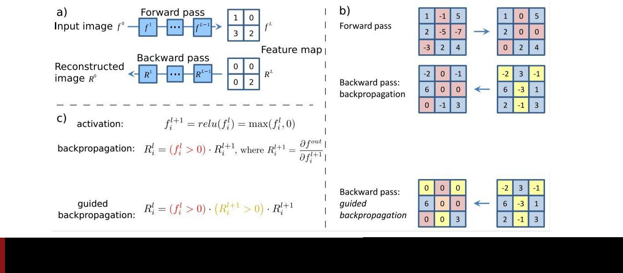

Fei-Fei Li & Andrej Karpathy & Justin Johnson Lecture 9 23 3 Feb 2016

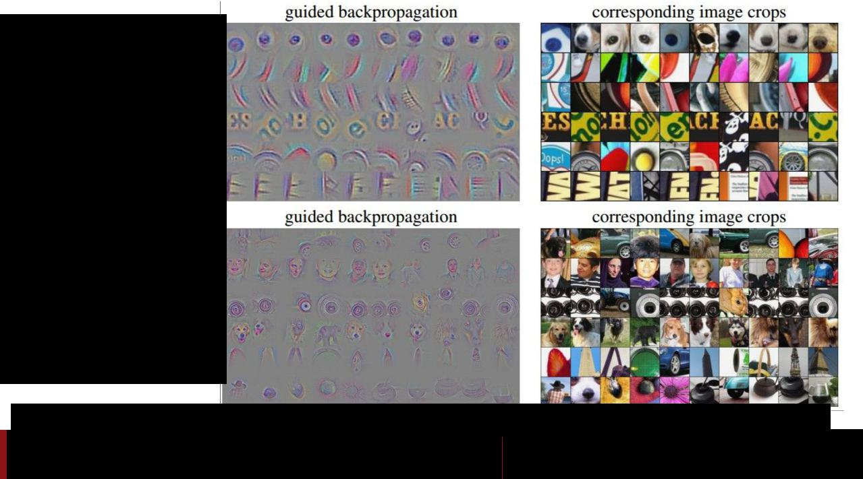Visualization of patterns learned by the layer **conv6** (top) and layer **conv9** (bottom) of the network trained on ImageNet.

Each row corresponds to one filter.

The visualization using “guided backpropagation” is based on the top 10 image patches activating this filter taken from the ImageNet dataset.

*[Striving for Simplicity: The all convolutional net, Springenberg, Dosovitskiy, et al., 2015]*

Fei-Fei Li & Andrej Karpathy & Justin Johnson Lecture 9 24 3 Feb 2016

Deconv approaches

*[Visualizing and Understanding Convolutional Networks, Zeiler and Fergus 2013]*

*[Deep Inside Convolutional Networks: Visualising Image Classification Models and Saliency Maps, Simonyan et al., 2014]*

*[Striving for Simplicity: The all convolutional net, Springenberg, Dosovitskiy, et al., 2015]*

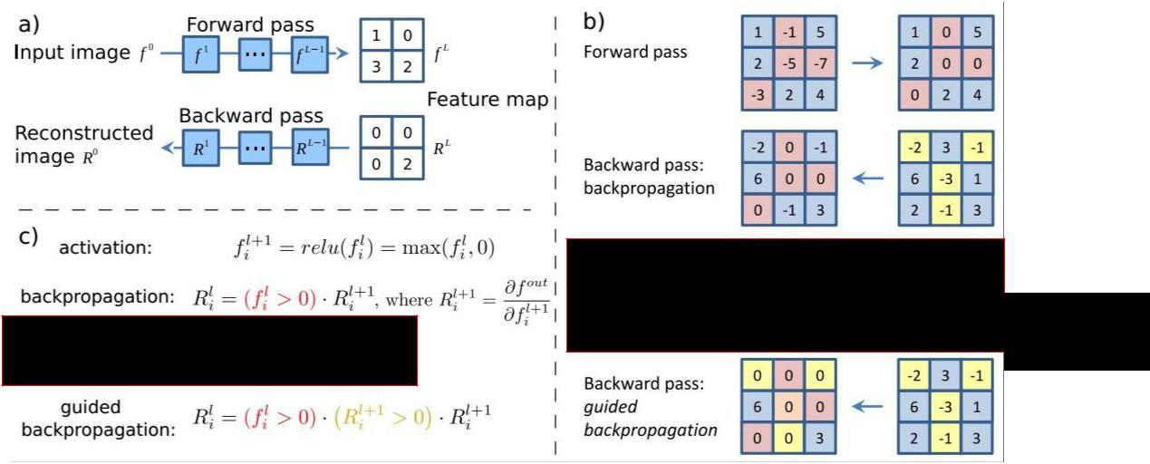

bit weird



Fei-Fei Li & Andrej Karpathy & Justin Johnson Lecture 9 25 3 Feb 2016

*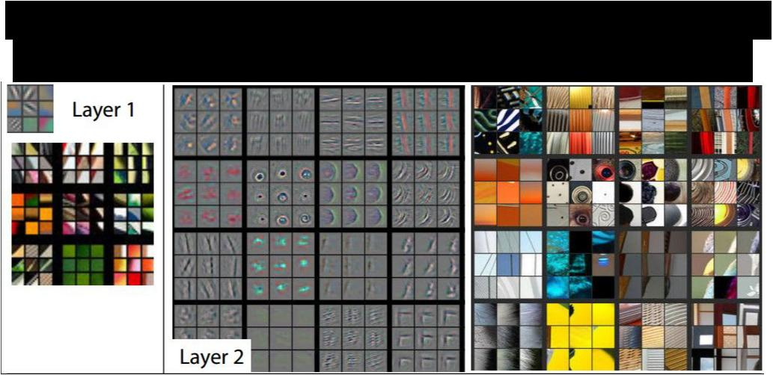Visualizing and Understanding Convolutional Networks*

*Zeiler & Fergus, 2013*

Visualizing arbitrary neurons along the way to the top...



Fei-Fei Li & Andrej Karpathy & Justin Johnson Lecture 9 26 3 Feb 2016

Visualizing arbitrary neurons along the way to the top...

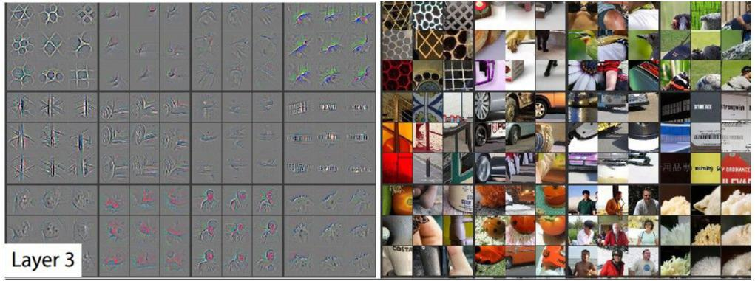

Fei-Fei Li & Andrej Karpathy & Justin Johnson Lecture 9 27 3 Feb 2016

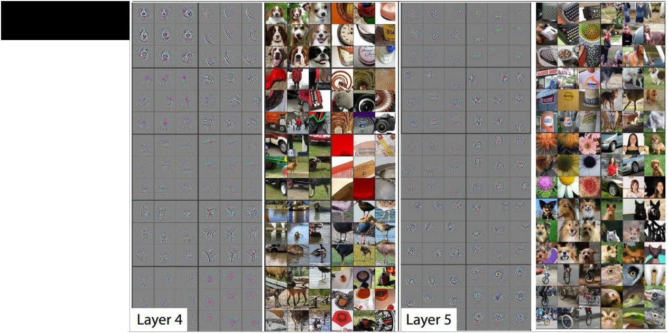Visualizing arbitrary neurons along the way to the top...



Fei-Fei Li & Andrej Karpathy & Justin Johnson Lecture 9 28 3 Feb 2016

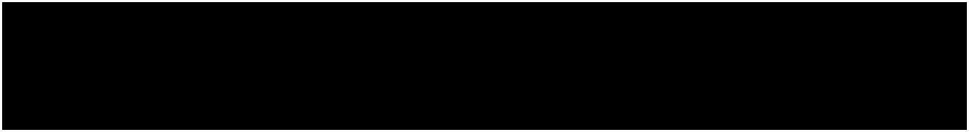Optimization to Image

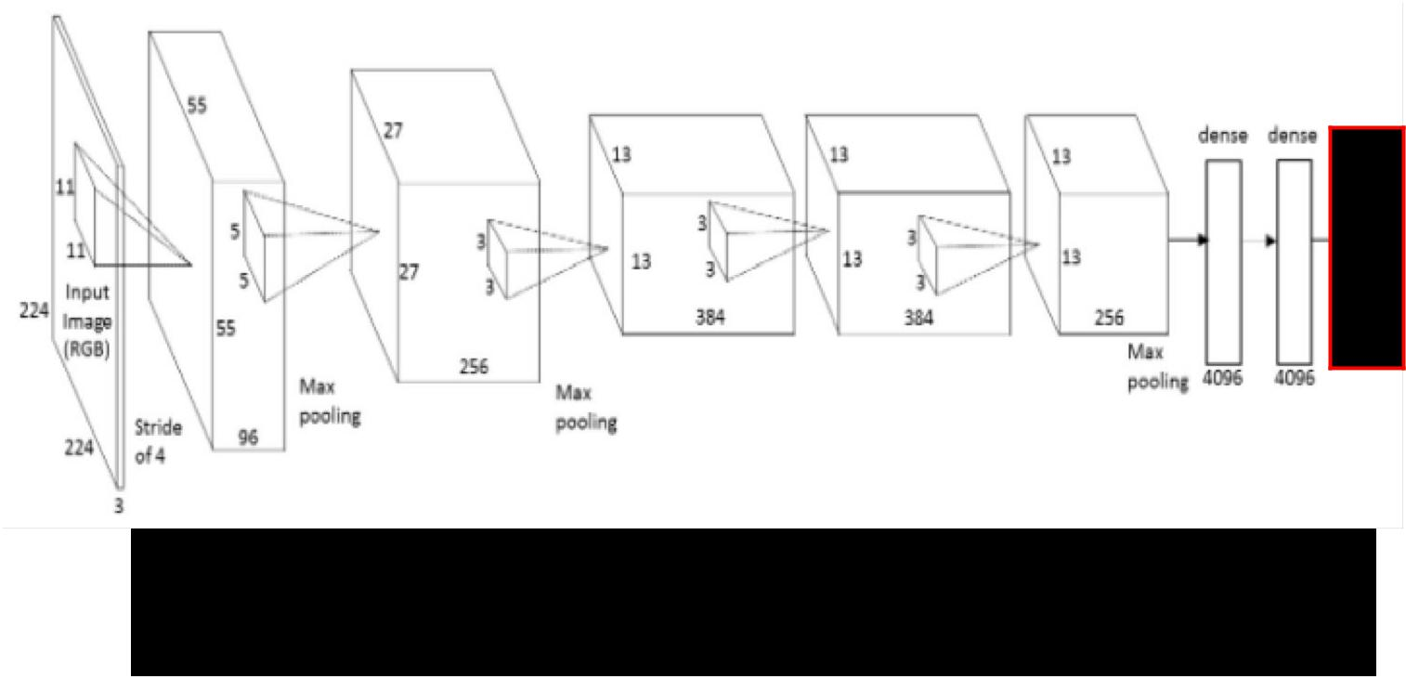

1. can we find an image that maximizes some class score?



Fei-Fei Li & Andrej Karpathy & Justin Johnson Lecture 9 29 3 Feb 2016

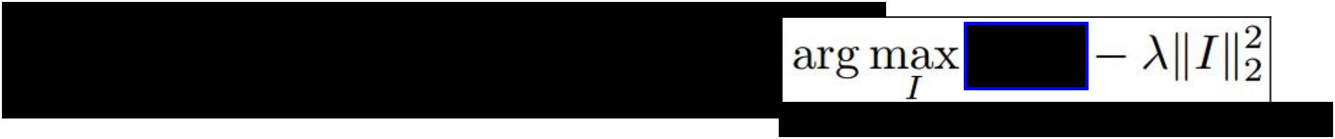

Optimization to Image

score for class c (before Softmax)



1. can we find an image that maximizes some class score?



|  |  |  |
| --- | --- | --- |
| Fei-Fei Li & Andrej Karpathy & Justin Johnson | Lecture 9 30 | 3 Feb 2016 |
|  |  |  |

Optimization to Image

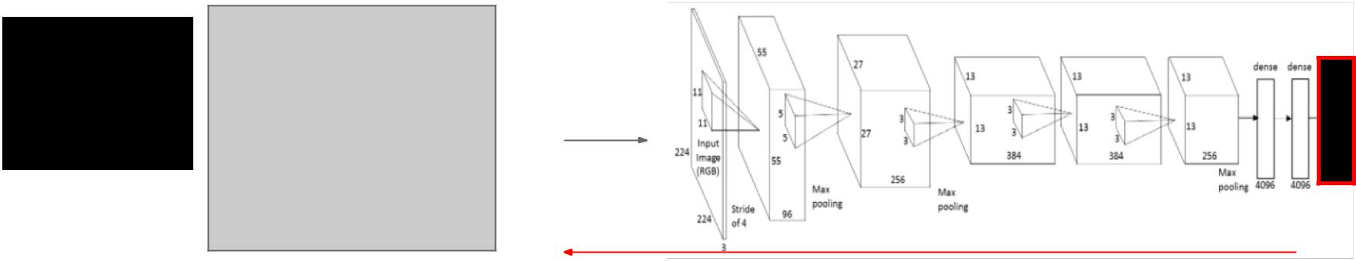

1. feed in zeros.

zero image



2. set the gradient of the scores vector to be [0,0,....1,....,0], then backprop to image



Fei-Fei Li & Andrej Karpathy & Justin Johnson Lecture 9 31 3 Feb 2016



Optimization to Image

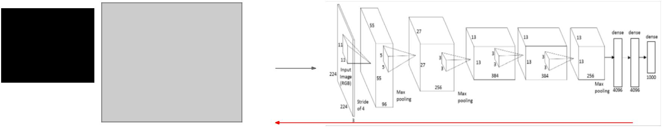

1. feed in zeros.

zero image



1. set the gradient of the scores vector to be [0,0,....1,....,0], then backprop to image
2. do a small “image update”
3. forward the image through the network.

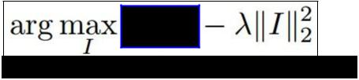

5. go back to 2.

score for class c (before Softmax)



|  |  |  |
| --- | --- | --- |
| Fei-Fei Li & Andrej Karpathy & Justin Johnson | Lecture 9 32 | 3 Feb 2016 |
|  |  |  |

*Deep Inside Convolutional Networks: Visualising Image Classification Models and Saliency Maps Karen Simonyan, Andrea Vedaldi, Andrew Zisserman, 2014*

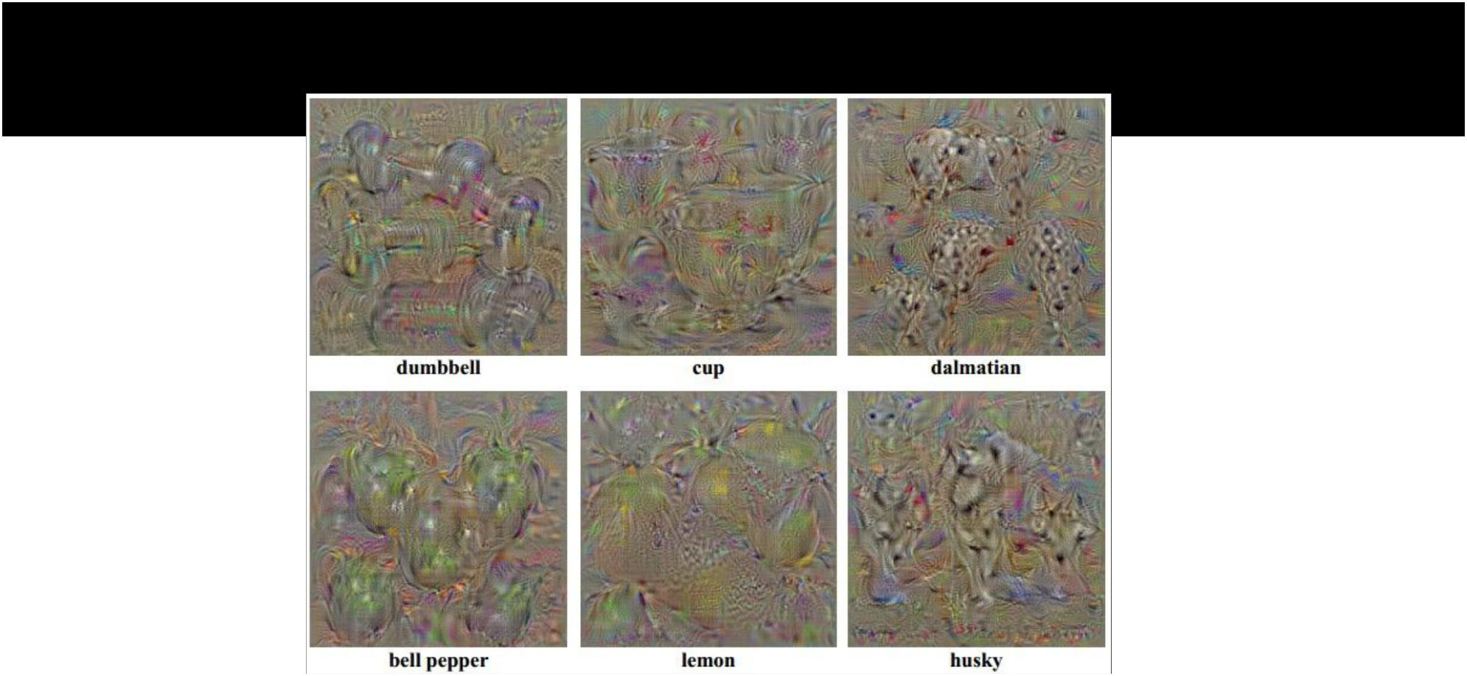

1. Find images that maximize some class score:



Fei-Fei Li & Andrej Karpathy & Justin Johnson Lecture 9 33 3 Feb 2016

*Deep Inside Convolutional Networks: Visualising Image Classification Models and Saliency Maps Karen Simonyan, Andrea Vedaldi, Andrew Zisserman, 2014*

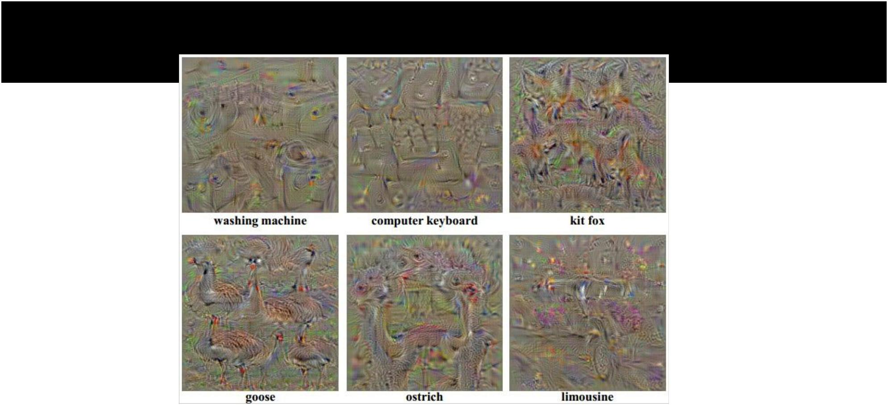

1. Find images that maximize some class score:



Fei-Fei Li & Andrej Karpathy & Justin Johnson Lecture 9 34 3 Feb 2016

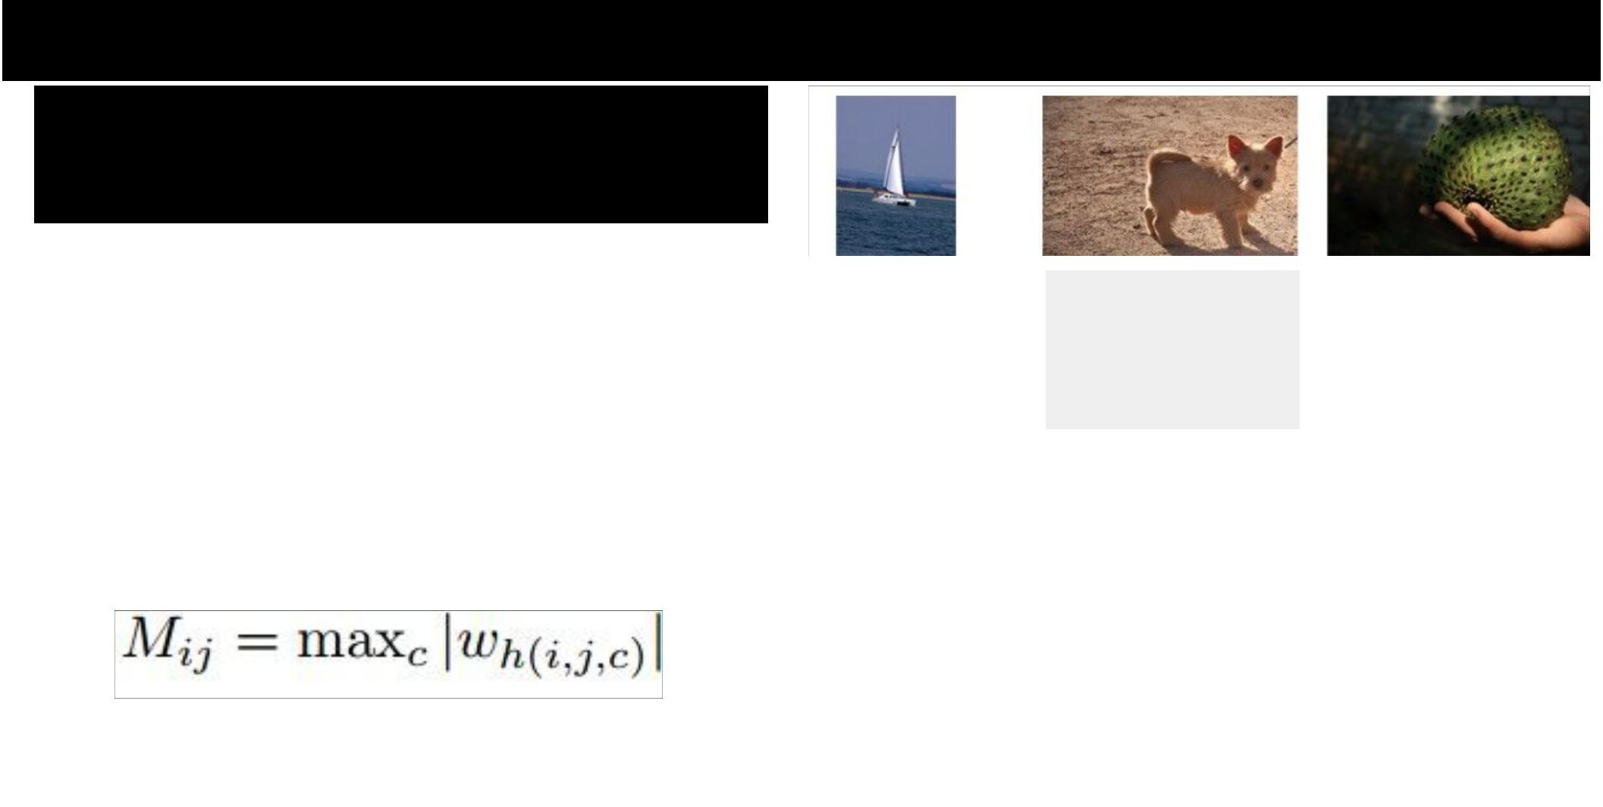

*Deep Inside Convolutional Networks: Visualising Image Classification Models and Saliency Maps Karen Simonyan, Andrea Vedaldi, Andrew Zisserman, 2014*

1. Visualize the Data gradient:

|  |  |  |
| --- | --- | --- |
| (note that the gradient on | M = ? |  |
| data has three channels. |  |  |
|  |  |
| Here they visualize M, s.t.: |  |  |

(at each pixel take abs val, and max over channels)



|  |  |  |
| --- | --- | --- |
| Fei-Fei Li & Andrej Karpathy & Justin Johnson | Lecture 9 35 | 3 Feb 2016 |
|  |  |  |

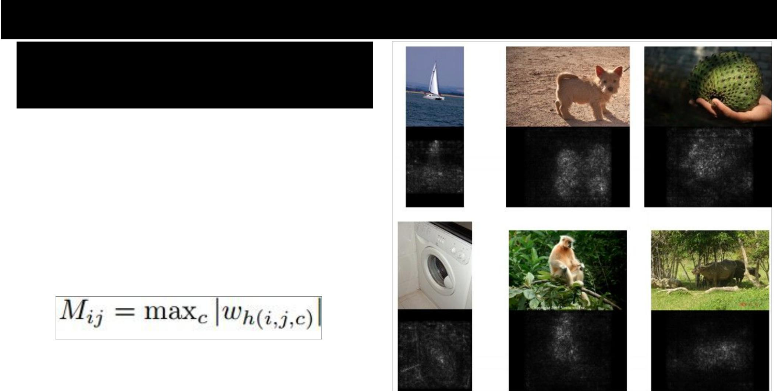

*Deep Inside Convolutional Networks: Visualising Image Classification Models and Saliency Maps Karen Simonyan, Andrea Vedaldi, Andrew Zisserman, 2014*

1. Visualize the Data gradient:

(note that the gradient on data has three channels. Here they visualize M, s.t.:

(at each pixel take abs val, and max over channels)



|  |  |  |
| --- | --- | --- |
| Fei-Fei Li & Andrej Karpathy & Justin Johnson | Lecture 9 36 | 3 Feb 2016 |
|  |  |  |

*Deep Inside Convolutional Networks: Visualising Image Classification Models and Saliency Maps Karen Simonyan, Andrea Vedaldi, Andrew Zisserman, 2014*

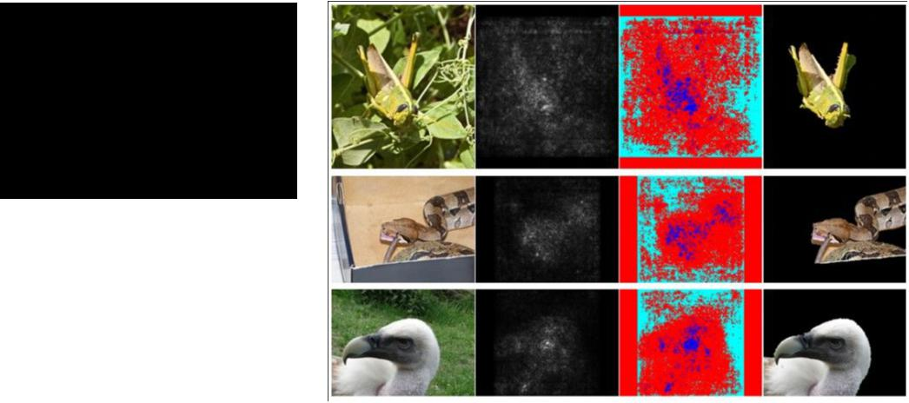

* Use **grabcut** for segmentation



Fei-Fei Li & Andrej Karpathy & Justin Johnson Lecture 9 37 3 Feb 2016

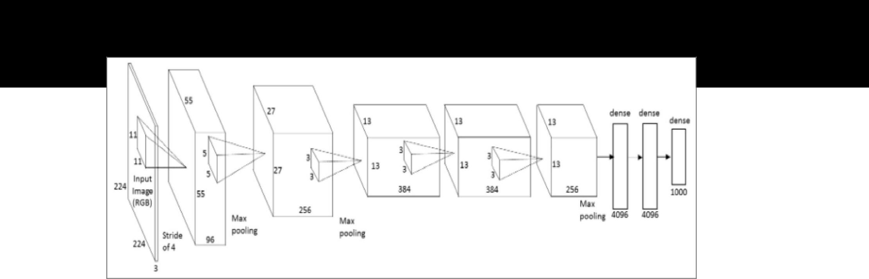We can in fact do this for arbitrary neurons along the ConvNet

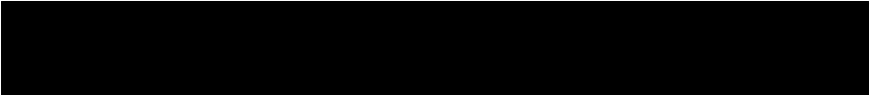

**Repeat:**

1. Forward an image
2. Set activations in layer of interest to all zero, except for a 1.0 for a neuron of interest
3. Backprop to image
4. Do an “image update”



Fei-Fei Li & Andrej Karpathy & Justin Johnson Lecture 9 38 3 Feb 2016

*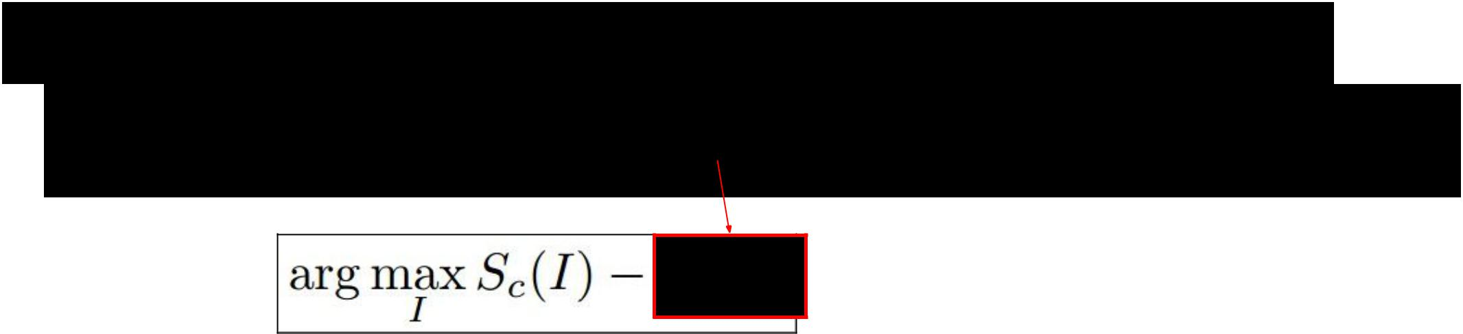[Understanding Neural Networks Through Deep Visualization, Yosinski et al. , 2015]*

Proposed a different form of regularizing the image



More explicit scheme:

**Repeat:**

* Update the image **x** with gradient from some unit of interest
* Blur x a bit
* Take any pixel with small norm to zero (to encourage sparsity)



Fei-Fei Li & Andrej Karpathy & Justin Johnson Lecture 9 39 3 Feb 2016

*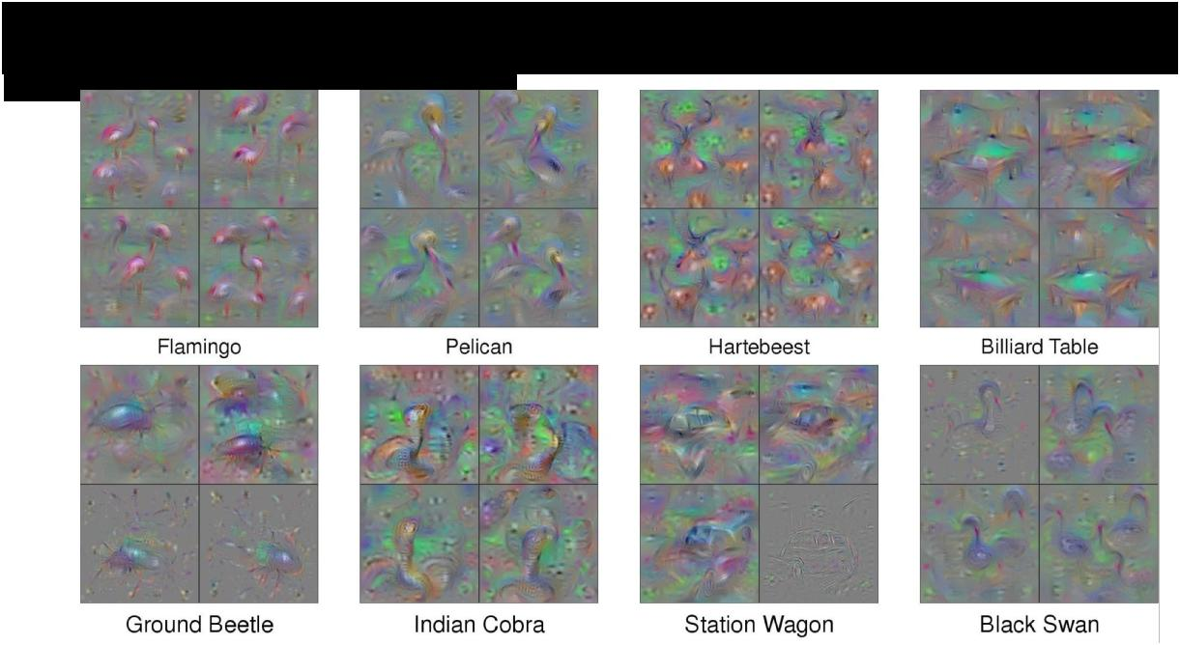[Understanding Neural Networks Through Deep Visualization, Yosinski et al. , 2015]*

<http://yosinski.com/deepvis>



Fei-Fei Li & Andrej Karpathy & Justin Johnson Lecture 9 40 3 Feb 2016

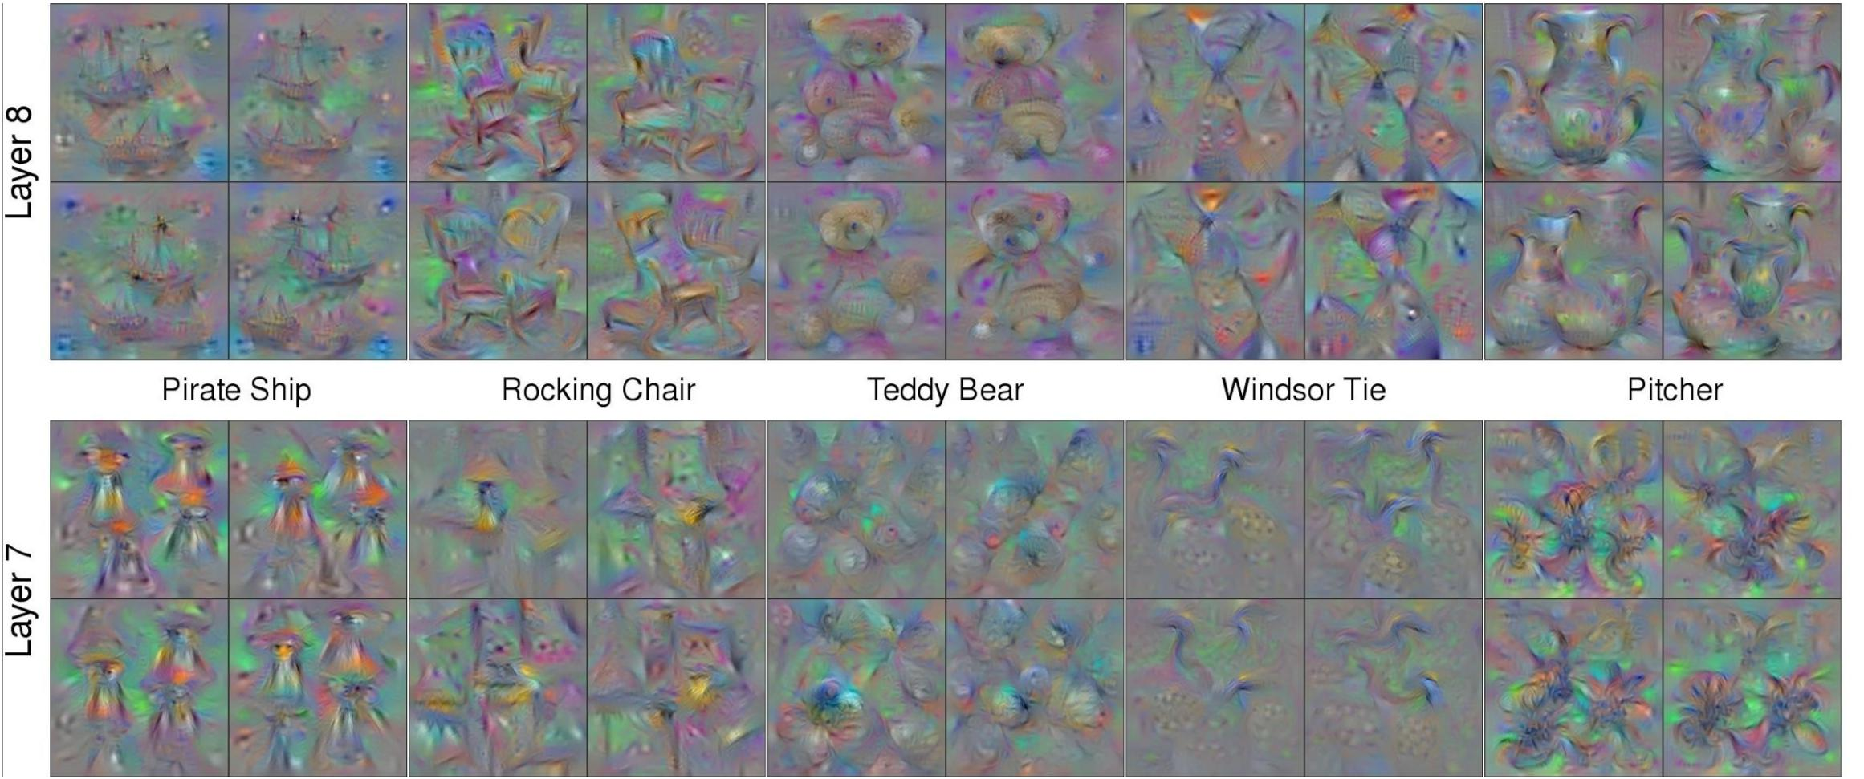

|  |  |  |
| --- | --- | --- |
| Fei-Fei Li & Andrej Karpathy & Justin Johnson | Lecture 9 41 | 3 Feb 2016 |
|  |  |  |

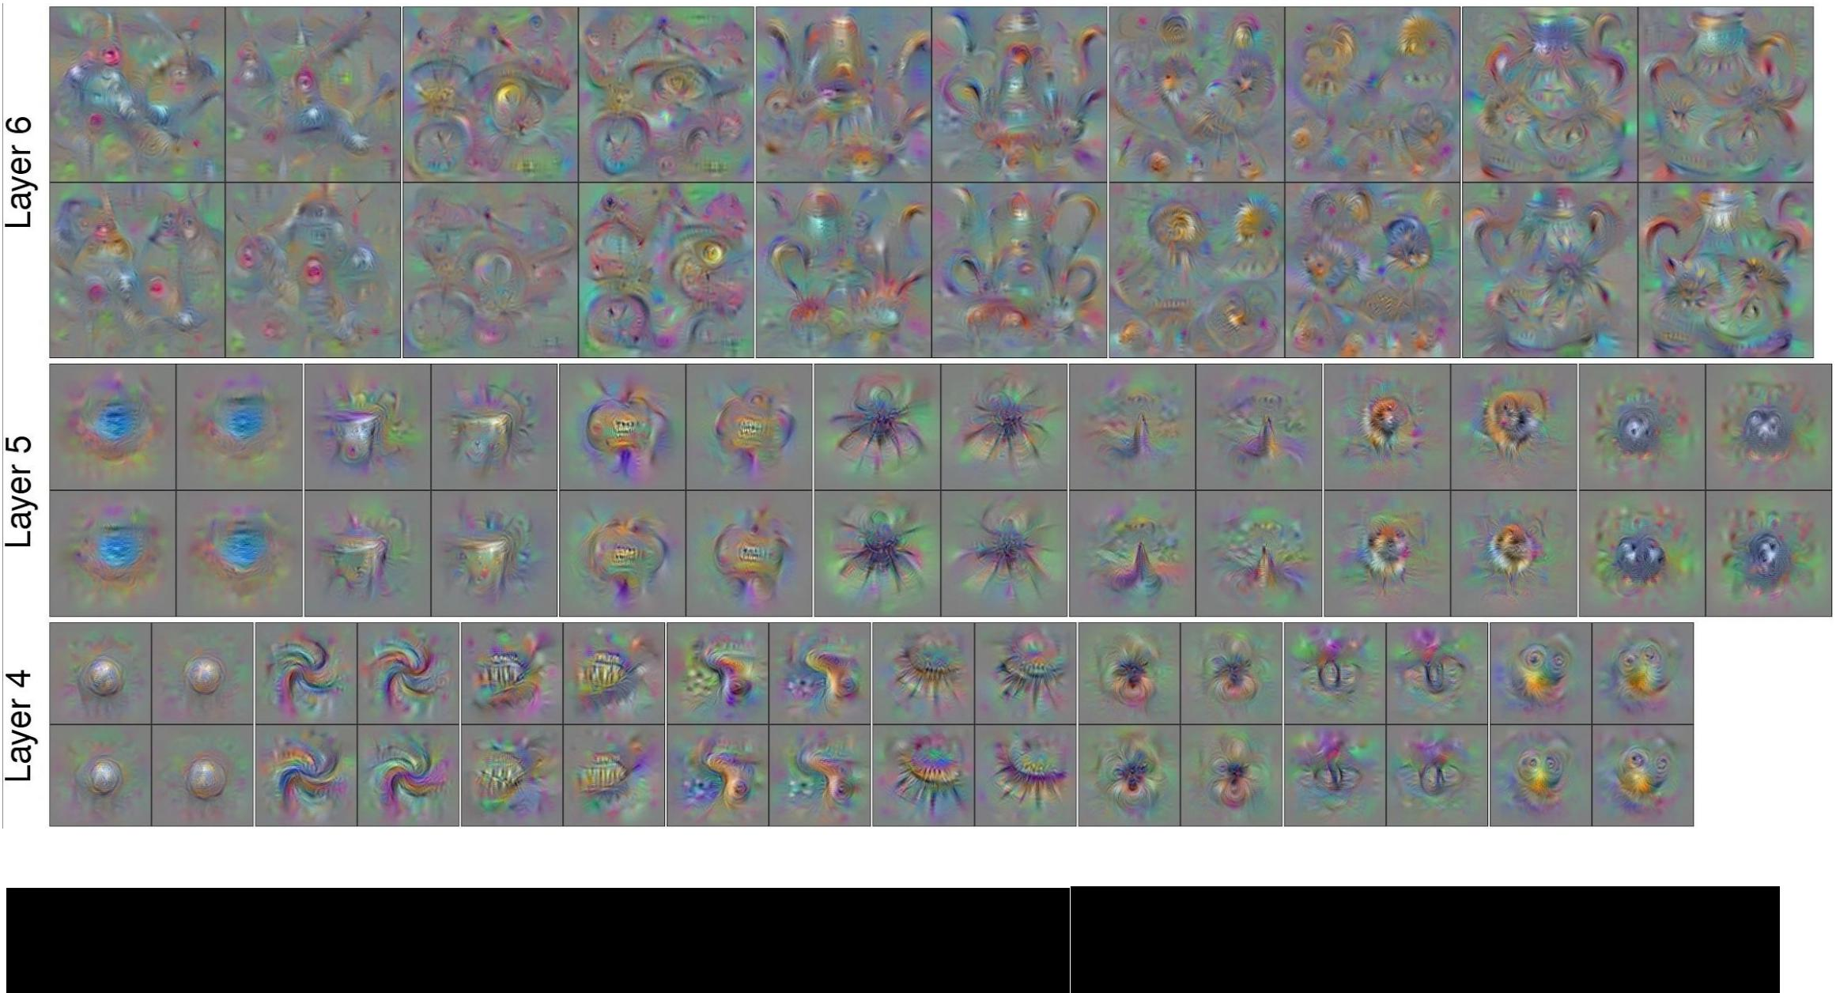

|  |  |  |
| --- | --- | --- |
| Fei-Fei Li & Andrej Karpathy & Justin Johnson | Lecture 9 42 | 3 Feb 2016 |
|  |  |  |

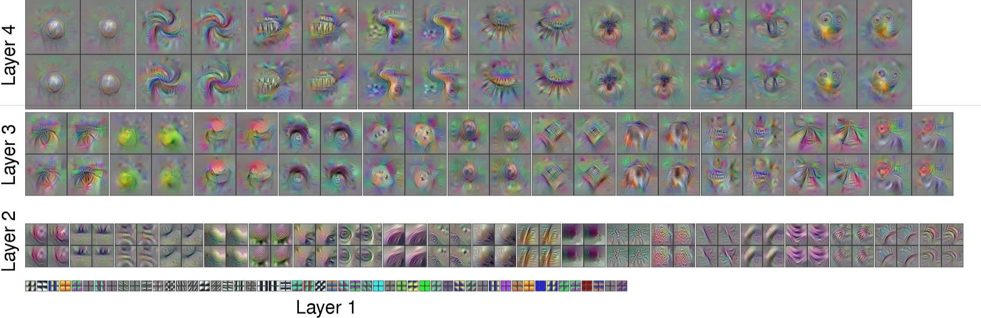

|  |  |  |
| --- | --- | --- |
| Fei-Fei Li & Andrej Karpathy & Justin Johnson | Lecture 9 43 | 3 Feb 2016 |
|  |  |  |

Question: Given a CNN code, is it possible to reconstruct the original image?

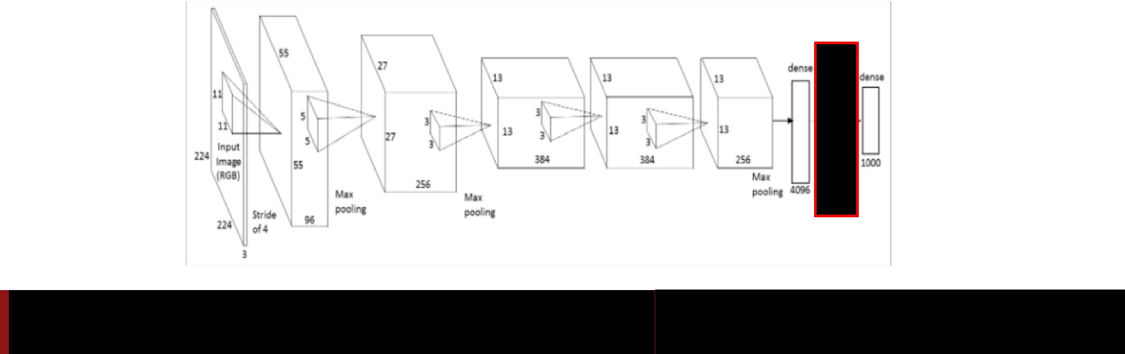

Fei-Fei Li & Andrej Karpathy & Justin Johnson Lecture 9 44 3 Feb 2016

Find an image such that:

* Its code is similar to a given code
* It “looks natural” (image prior regularization)

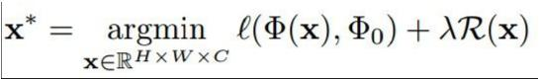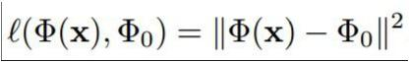

Fei-Fei Li & Andrej Karpathy & Justin Johnson Lecture 9 45 3 Feb 2016

*Understanding Deep Image Representations by Inverting Them [Mahendran and Vedaldi, 2014]*

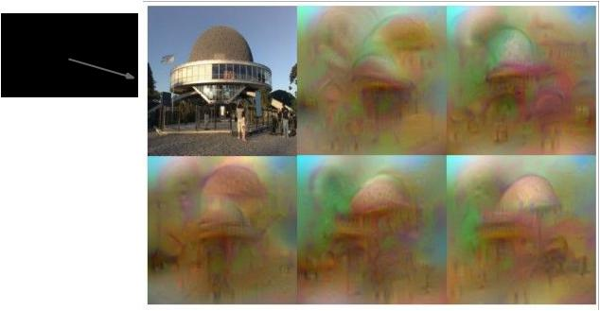

original image

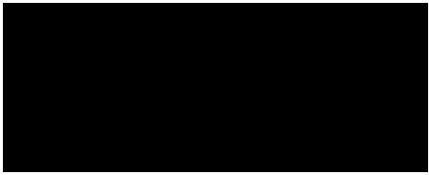

reconstructions from the 1000 log probabilities for ImageNet (ILSVRC) classes



Fei-Fei Li & Andrej Karpathy & Justin Johnson Lecture 9 46 3 Feb 2016

Reconstructions from the representation after last last pooling layer (immediately before the first Fully Connected layer)

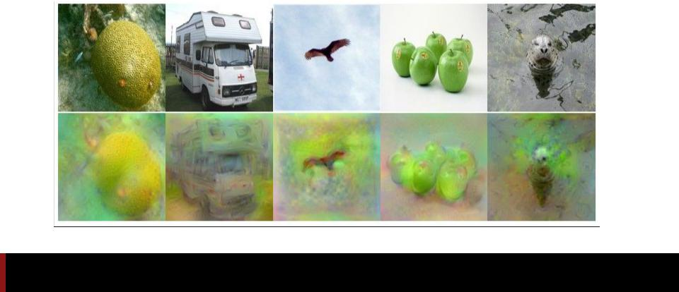

Fei-Fei Li & Andrej Karpathy & Justin Johnson Lecture 9 47 3 Feb 2016

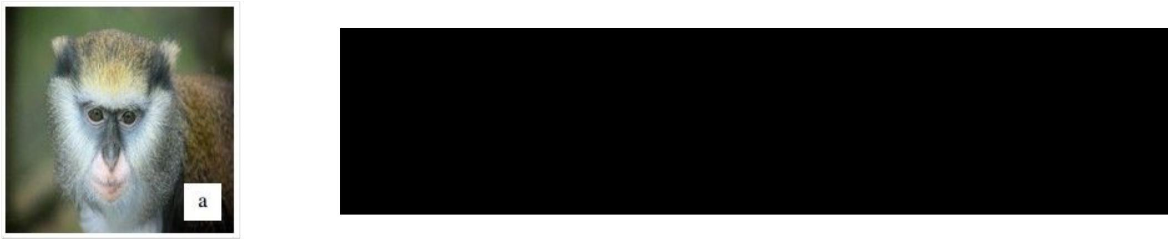Reconstructions from intermediate layers

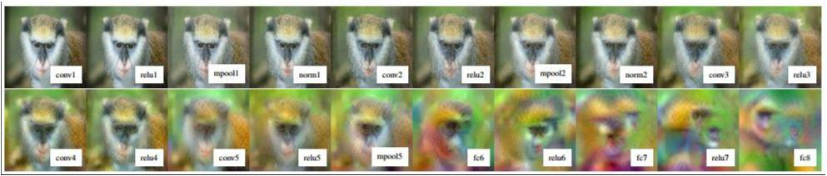

Fei-Fei Li & Andrej Karpathy & Justin Johnson Lecture 9 48 3 Feb 2016

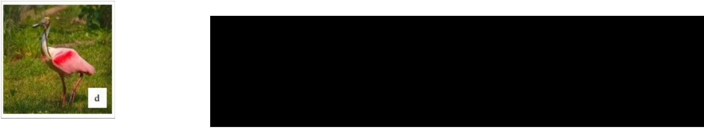Multiple reconstructions. Images in quadrants all “look” the same to the CNN (same code)

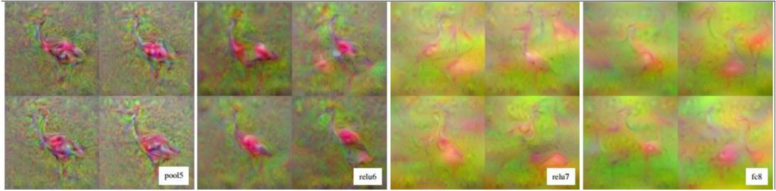

Fei-Fei Li & Andrej Karpathy & Justin Johnson Lecture 9 49 3 Feb 2016

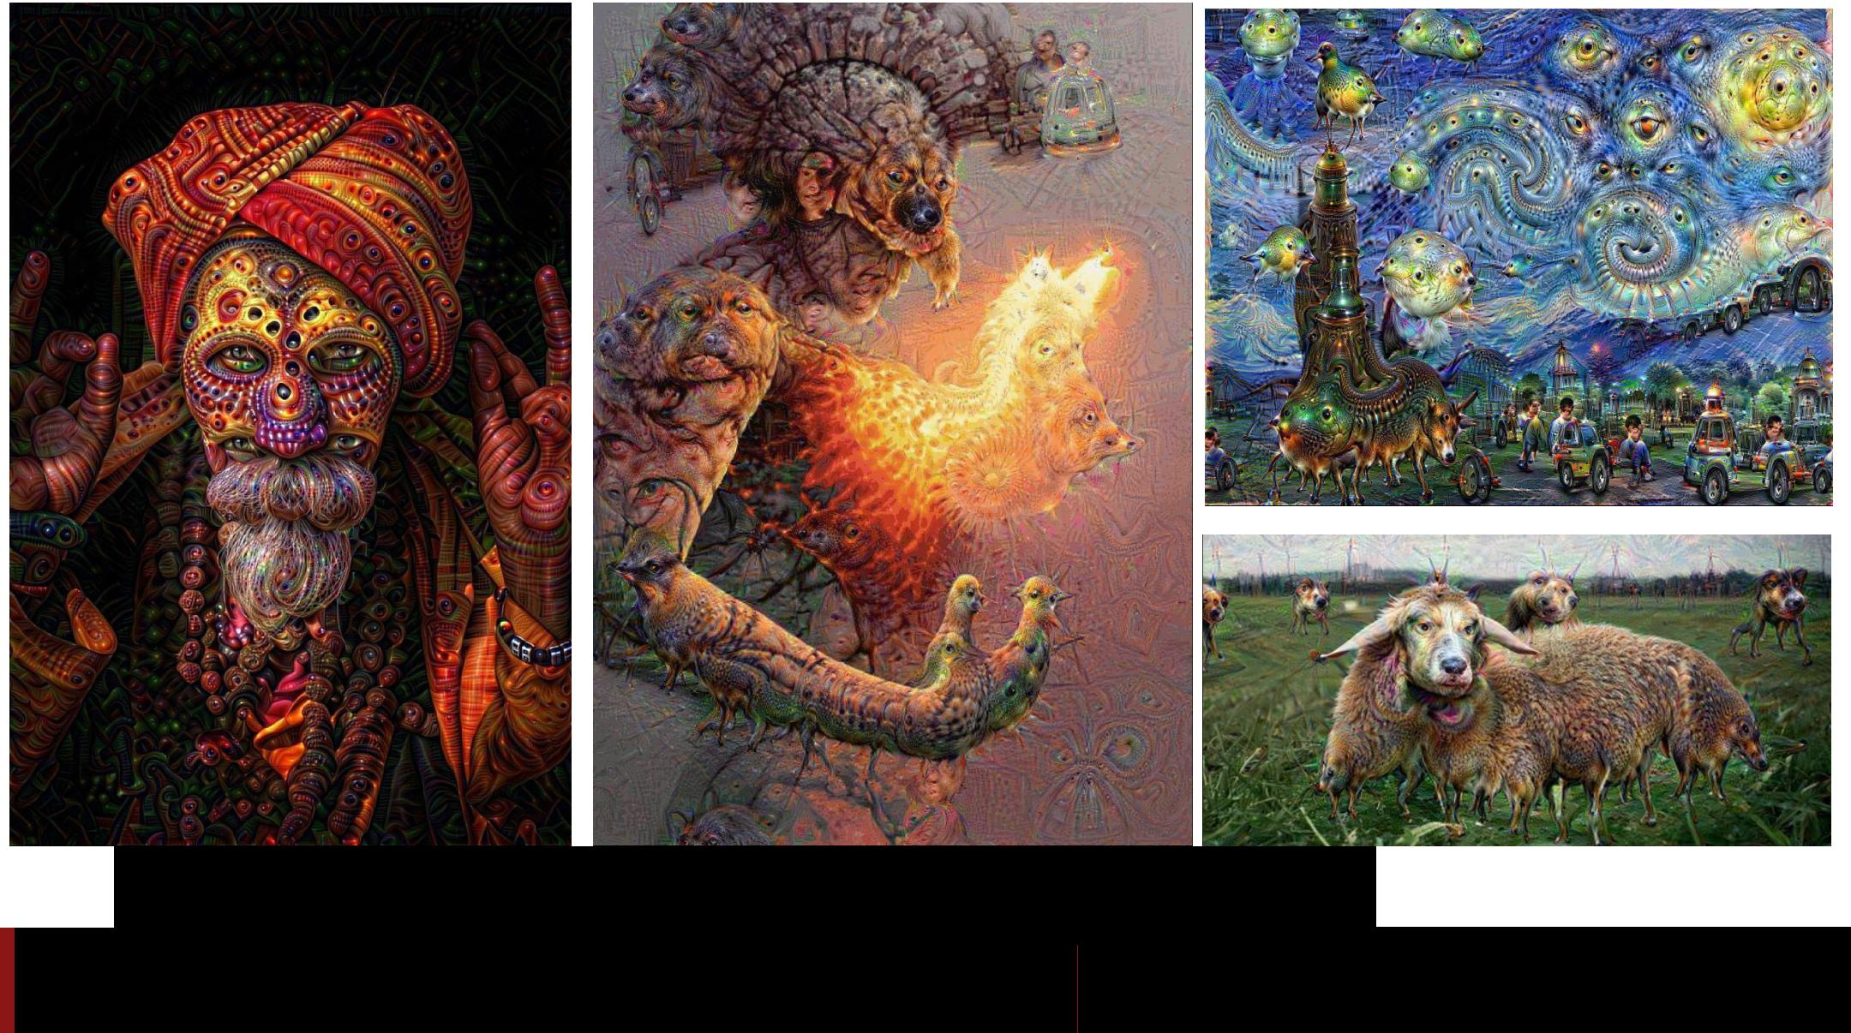

DeepDream <https://github.com/google/deepdream>

Fei-Fei Li & Andrej Karpathy & Justin Johnson Lecture 9 50 3 Feb 2016

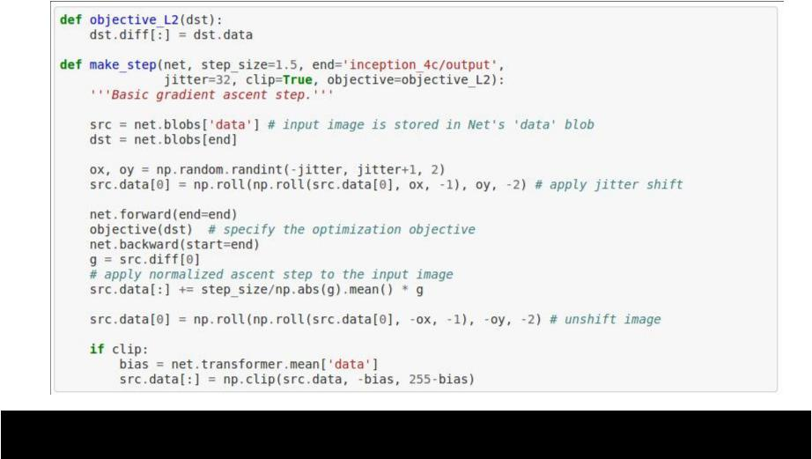

|  |  |  |
| --- | --- | --- |
| Fei-Fei Li & Andrej Karpathy & Justin Johnson | Lecture 9 51 | 3 Feb 2016 |
|  |  |  |

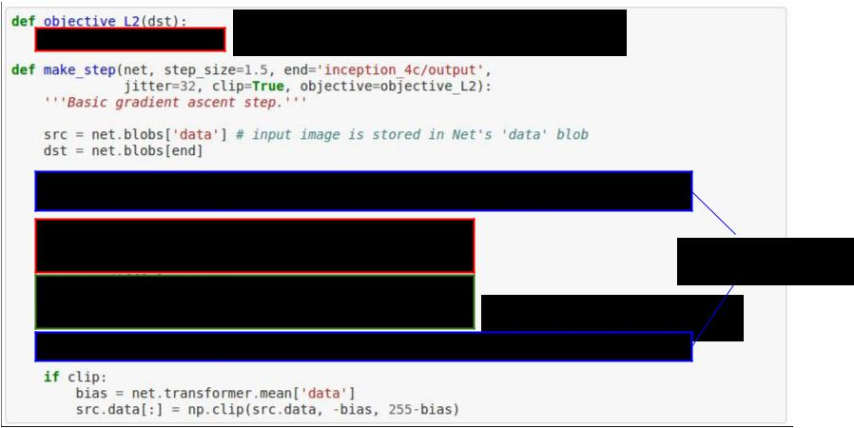DeepDream: set dx = x :)

jitter regularizer

“image update”



Fei-Fei Li & Andrej Karpathy & Justin Johnson Lecture 9 52 3 Feb 2016

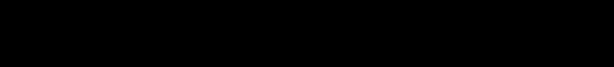

inception_4c/output

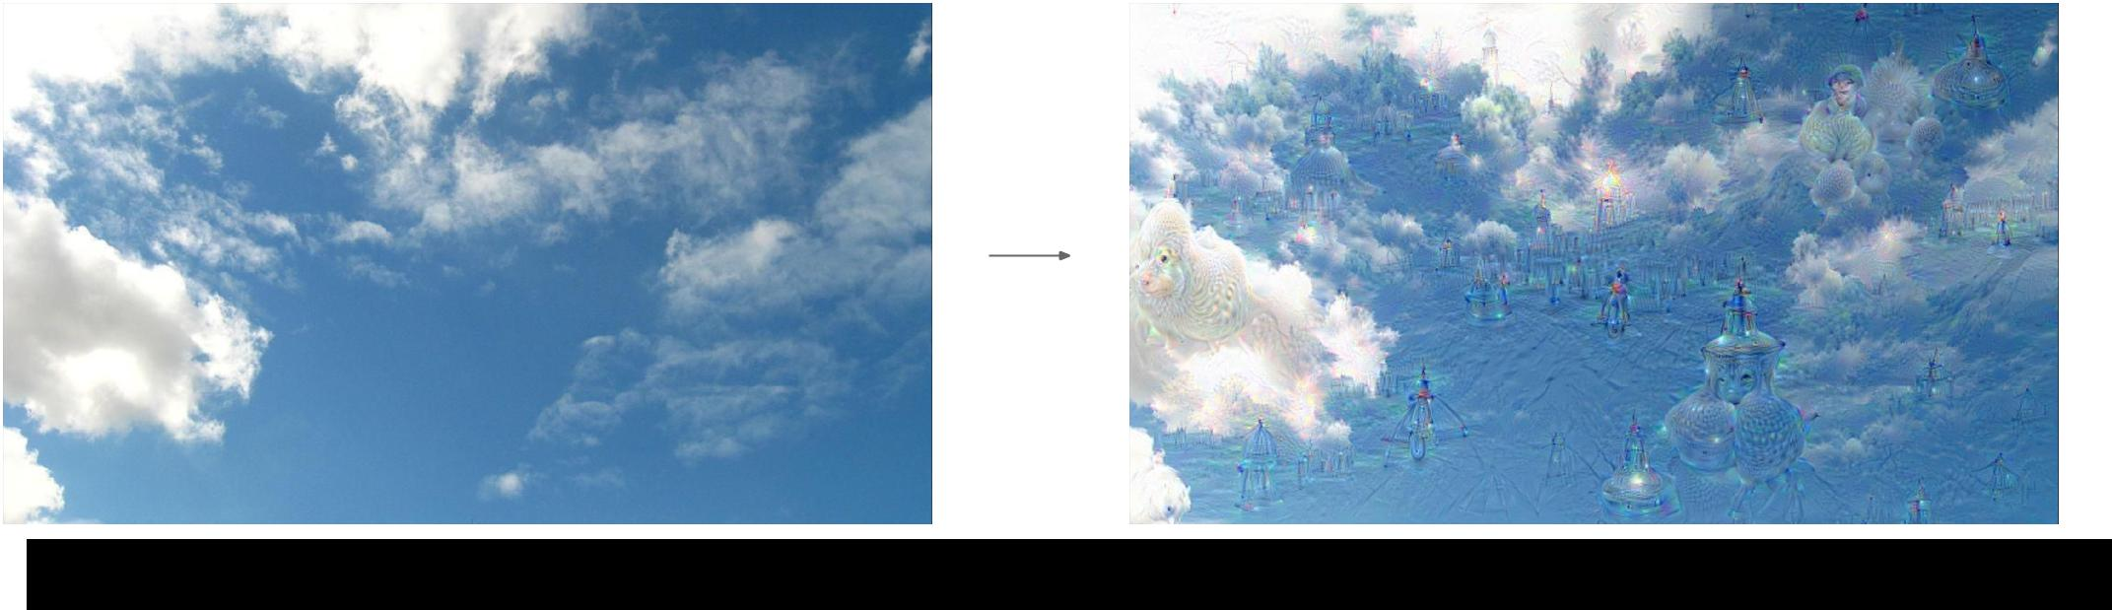

DeepDream modifies the image in a way that “boosts” all activations, at any layer

this creates a feedback loop: e.g. any slightly detected dog face will be made more and more dog like over time



|  |  |  |
| --- | --- | --- |
| Fei-Fei Li & Andrej Karpathy & Justin Johnson | Lecture 9 53 | 3 Feb 2016 |
|  |  |  |

inception_4c/output

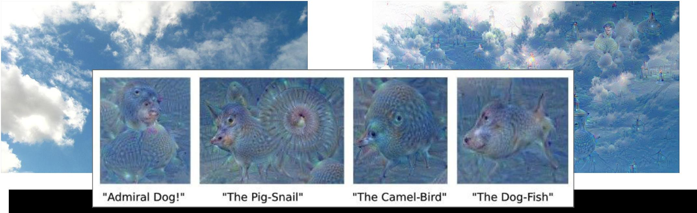

DeepDream any layer



Fei-Fei Li & Andrej Karpathy & Justin Johnson Lecture 9 54 3 Feb 2016

inception_3b/5x5_reduce

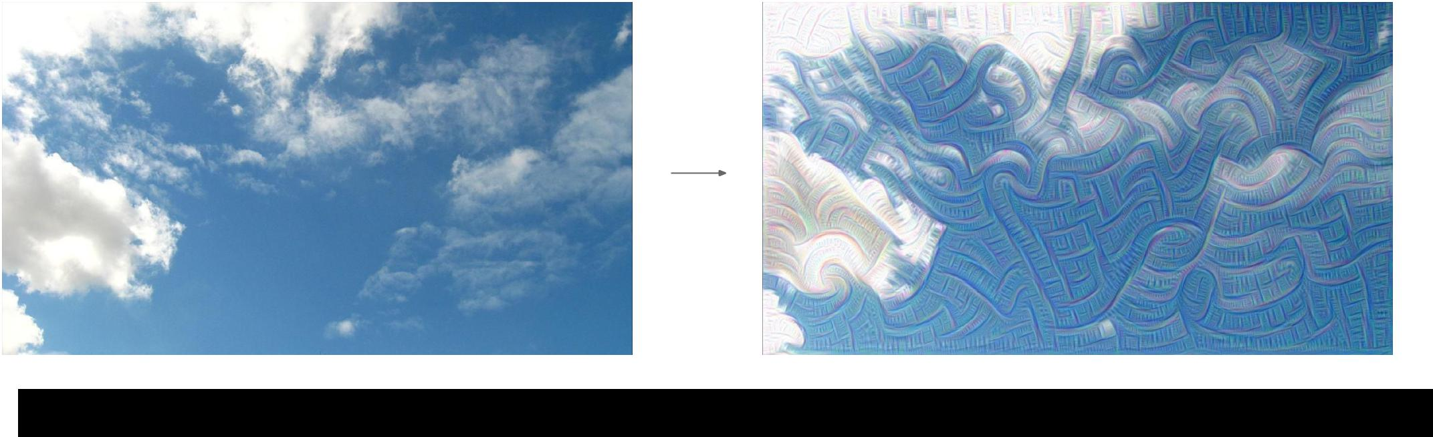

DeepDream modifies the image in a way that “boosts” all activations, at any layer



Fei-Fei Li & Andrej Karpathy & Justin Johnson Lecture 9 55 3 Feb 2016

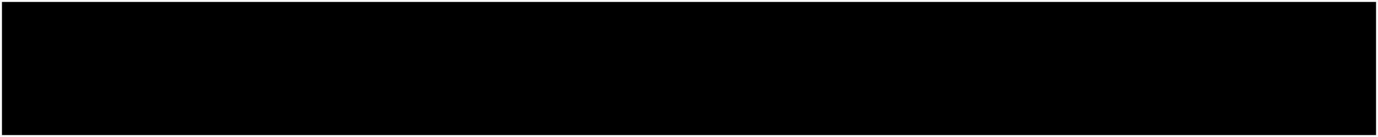Bonus videos

Deep Dream Grocery Trip <https://www.youtube.com/watch?v=DgPaCWJL7XI>

Deep Dreaming Fear & Loathing in Las Vegas: the Great San Francisco Acid Wave <https://www.youtube.com/watch?v=oyxSerkkP4o>



Fei-Fei Li & Andrej Karpathy & Justin Johnson Lecture 9 56 3 Feb 2016

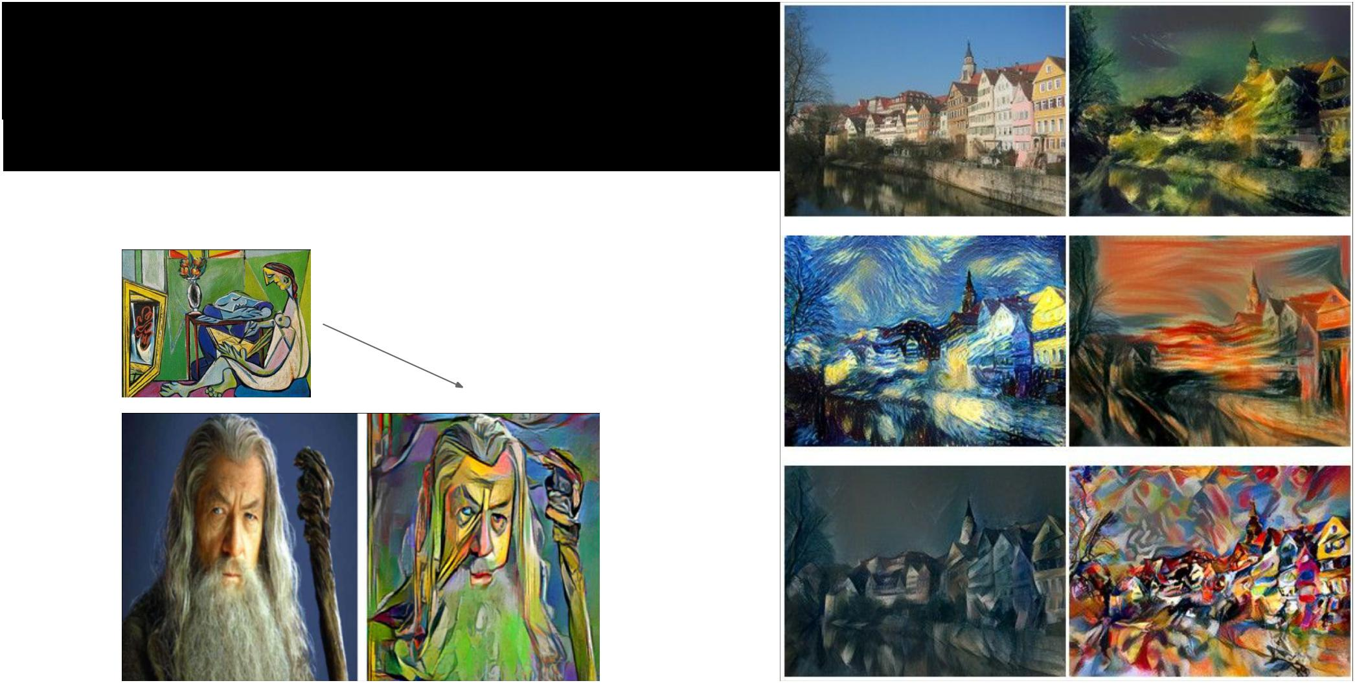NeuralStyle

* *A Neural Algorithm of Artistic Style by Leon A. Gatys, Alexander S. Ecker, and Matthias Bethge, 2015]* **good implementation by Justin in Torch:** [**https://github.com/jcjohnson/neural-style**](https://github.com/jcjohnson/neural-style)



Fei-Fei Li & Andrej Karpathy & Justin Johnson Lecture 9 57 3 Feb 2016

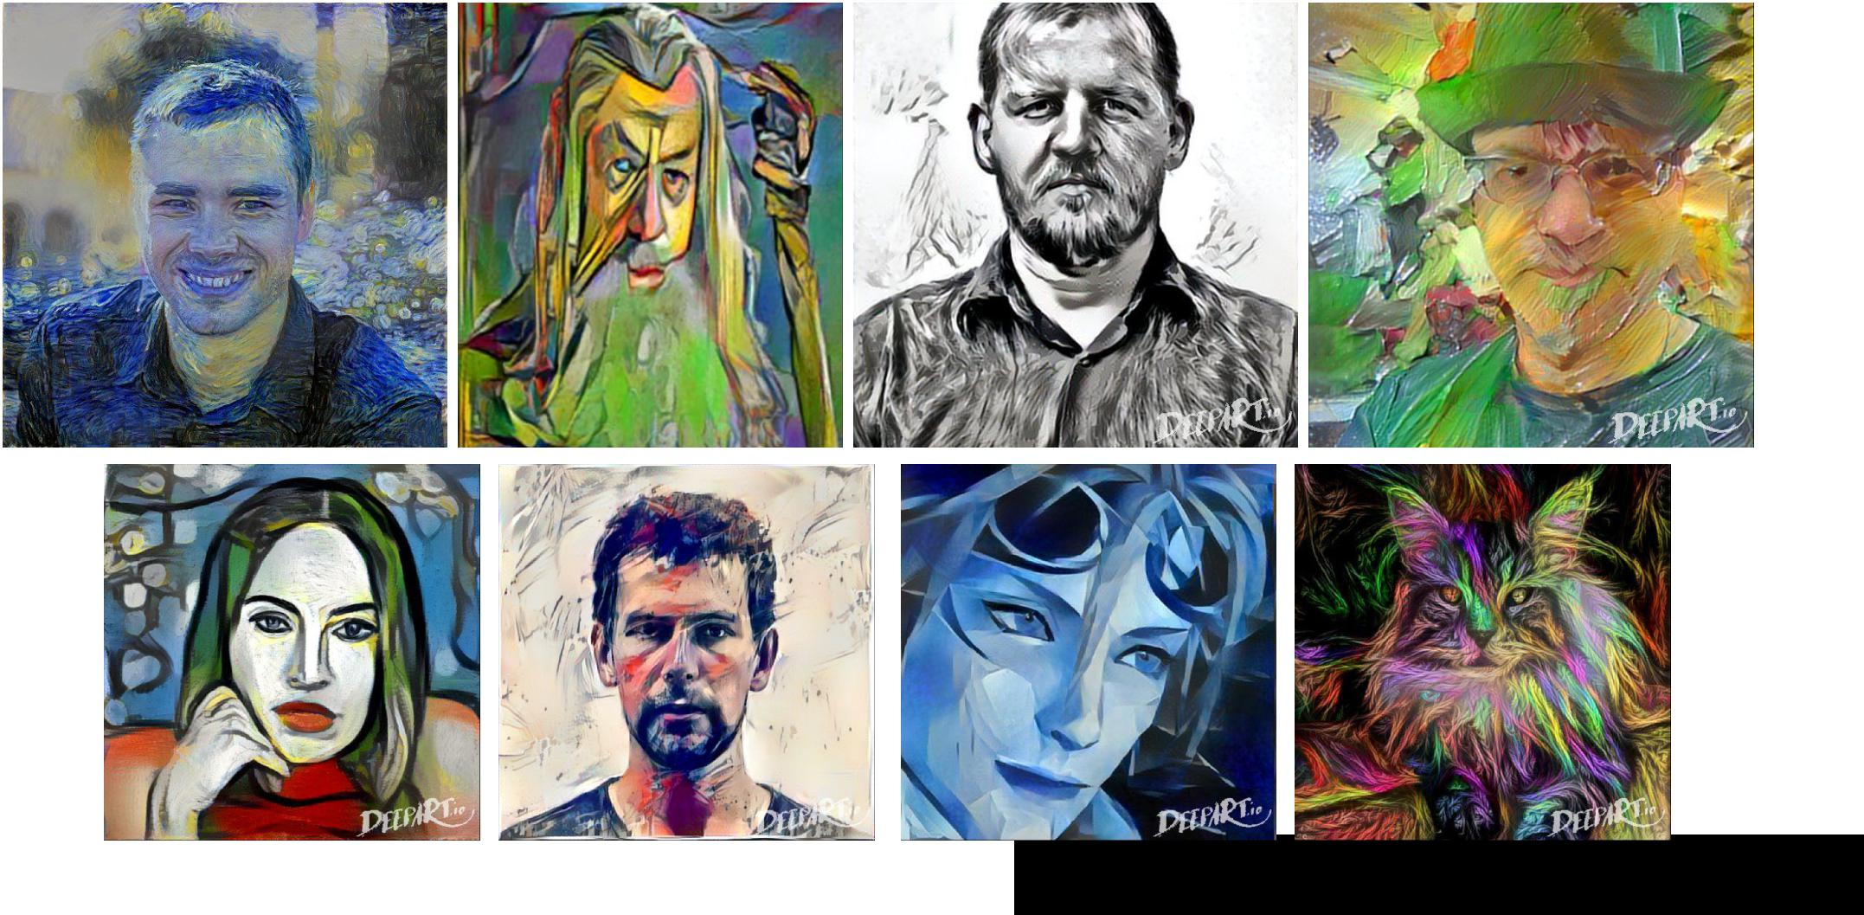

make your own easily on deepart.io



|  |  |  |
| --- | --- | --- |
| Fei-Fei Li & Andrej Karpathy & Justin Johnson | Lecture 9 58 | 3 Feb 2016 |
|  |  |  |

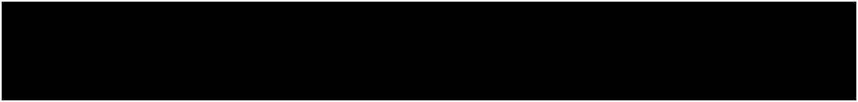Step 1: Extract **content targets** (ConvNet activations of all layers for the given content image)

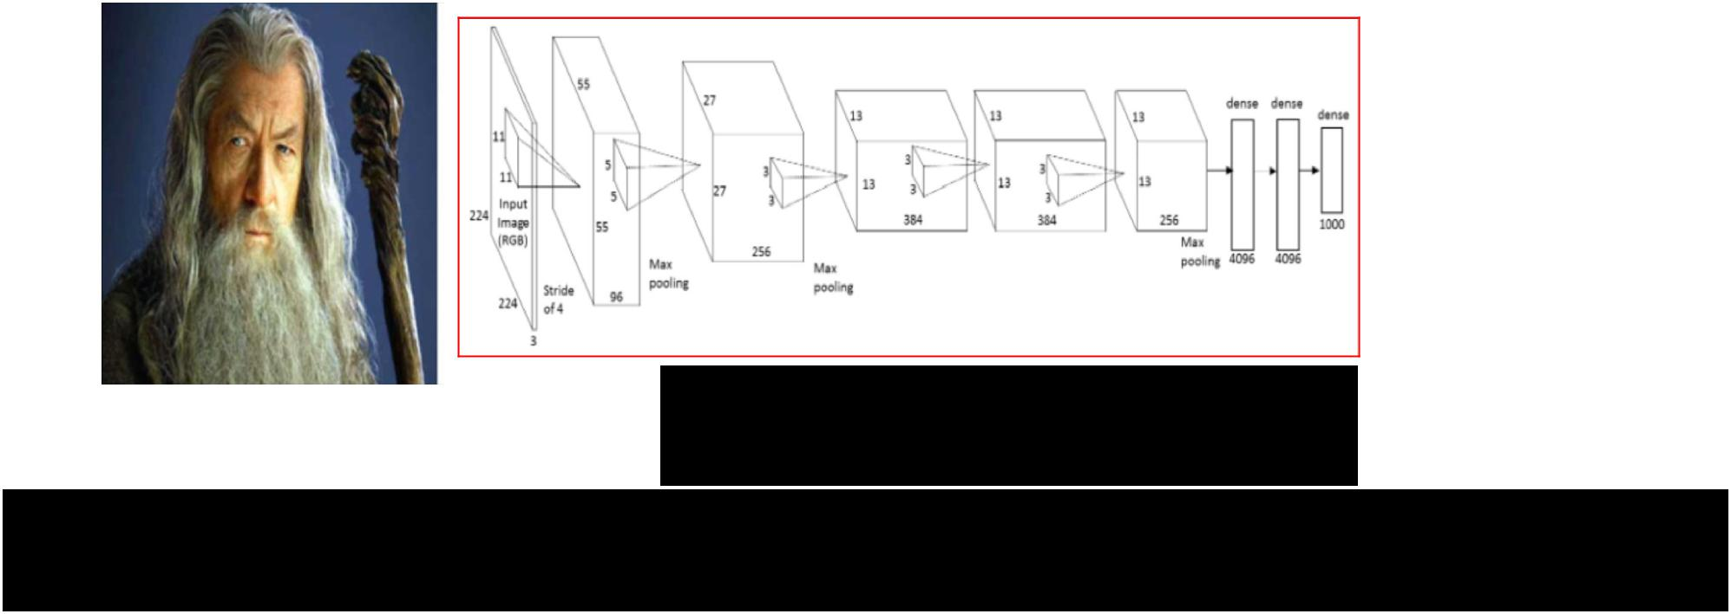

content activations

e.g.

at CONV5_1 layer we would have a [14x14x512] array of target activations



Fei-Fei Li & Andrej Karpathy & Justin Johnson Lecture 9 59 3 Feb 2016



Step 2: Extract **style targets** (Gram matrices of ConvNet activations of all layers for the given style image)

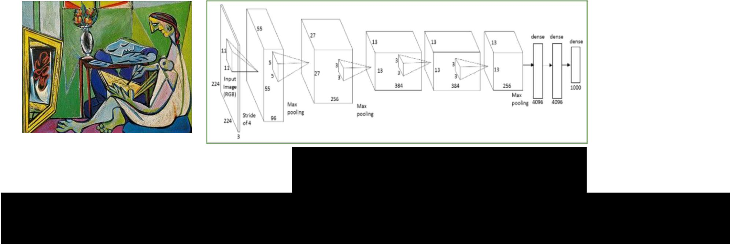

style gram matrices

e.g.  at CONV1 layer (with [224x224x64] activations) would give a [64x64] Gram matrix of all pairwise activation covariances (summed across spatial locations)



|  |  |  |
| --- | --- | --- |
| Fei-Fei Li & Andrej Karpathy & Justin Johnson | Lecture 9 60 | 3 Feb 2016 |
|  |  |  |

Step 3: Optimize over image to have:

* The **content** of the content image (activations match content)
* The **style** of the style image (Gram matrices of activations match style)

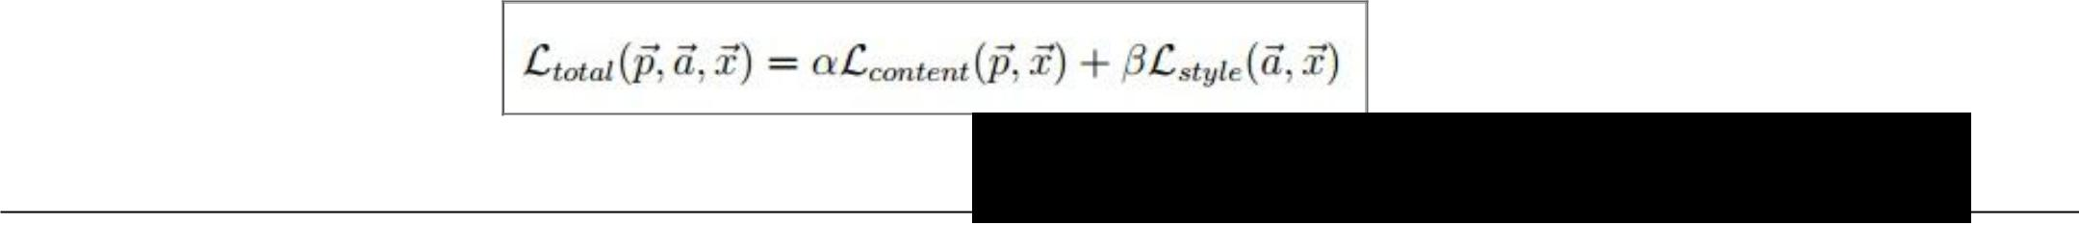

(+Total Variation regularization (maybe))

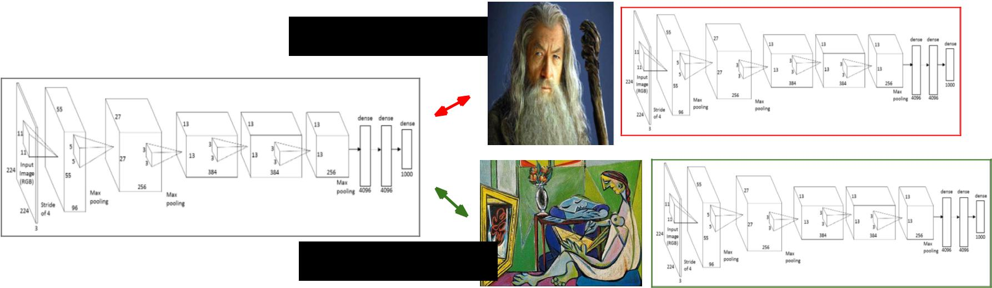

match content

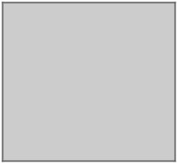

match style



Fei-Fei Li & Andrej Karpathy & Justin Johnson Lecture 9 61 3 Feb 2016

We can pose an optimization over the input image to maximize any class score. That seems useful.

Question: Can we use this to “fool” ConvNets?



spoiler alert: yeah

Fei-Fei Li & Andrej Karpathy & Justin Johnson Lecture 9 62 3 Feb 2016

*[Intriguing properties of neural networks, Szegedy et al., 2013]*

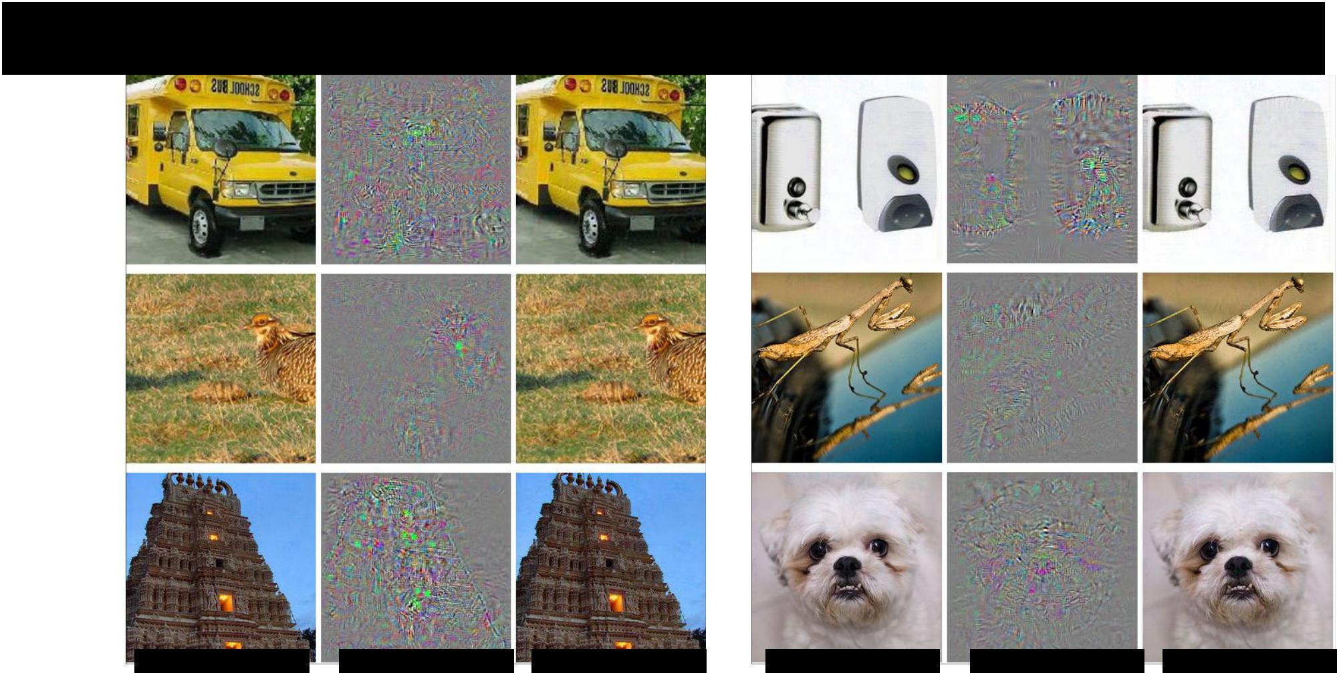

|  |  |  |  |  |  |  |
| --- | --- | --- | --- | --- | --- | --- |
| correct | +distort | ostrich | correct | +distort | ostrich | |
|  | | |  | |  |  |
| Fei-Fei Li & Andrej Karpathy & Justin Johnson | | | Lecture 9 63 | |  | 3 Feb 2016 |
|  |  |  |  |  |  |  |



*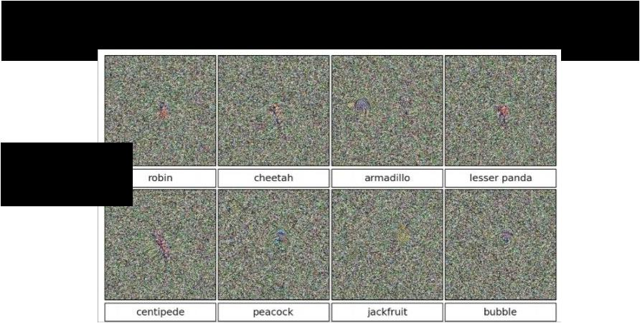[Deep Neural Networks are Easily Fooled: High Confidence Predictions for Unrecognizable Images Nguyen, Yosinski, Clune, 2014]*

>99.6% confidences



Fei-Fei Li & Andrej Karpathy & Justin Johnson Lecture 9 64 3 Feb 2016

*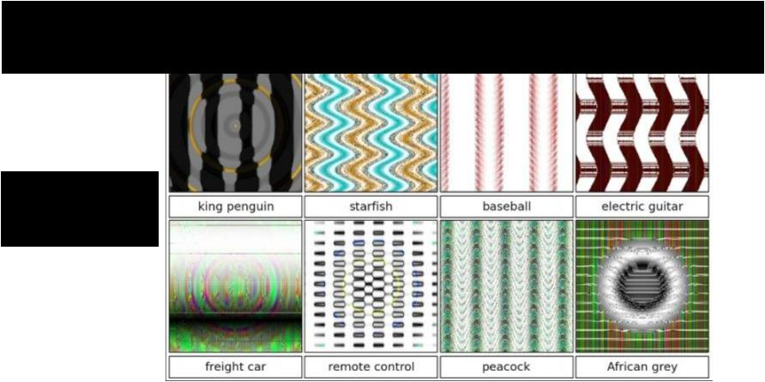[Deep Neural Networks are Easily Fooled: High Confidence Predictions for Unrecognizable Images Nguyen, Yosinski, Clune, 2014]*

>99.6% confidences



Fei-Fei Li & Andrej Karpathy & Justin Johnson Lecture 9 65 3 Feb 2016

These kinds of results were around even before ConvNets…

*[Exploring the Representation Capabilities of the HOG Descriptor, Tatu et al., 2011]*

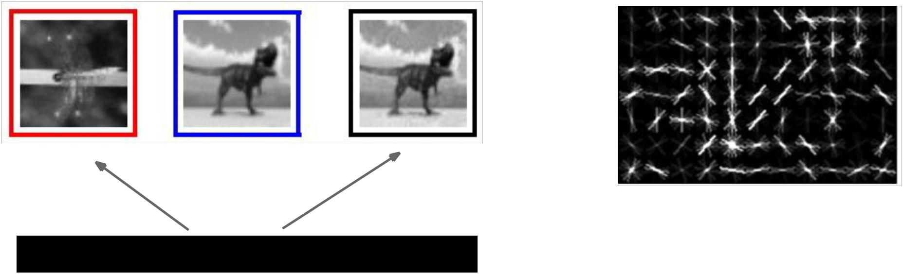

Identical HOG represention



Fei-Fei Li & Andrej Karpathy & Justin Johnson Lecture 9 66 3 Feb 2016

*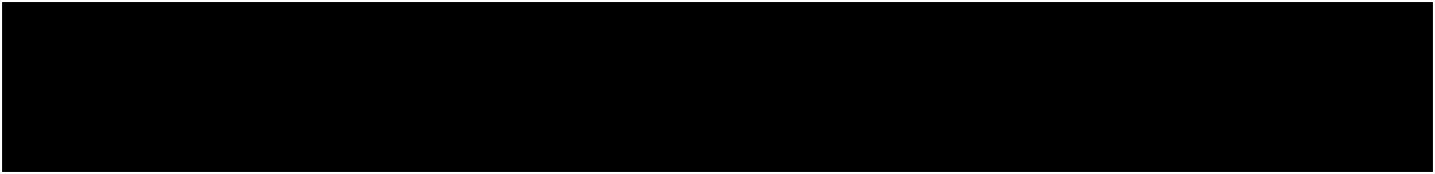EXPLAINING AND HARNESSING ADVERSARIAL EXAMPLES [Goodfellow, Shlens & Szegedy, 2014]*

“primary cause of neural networks’ vulnerability to adversarial perturbation is their **linear nature**“

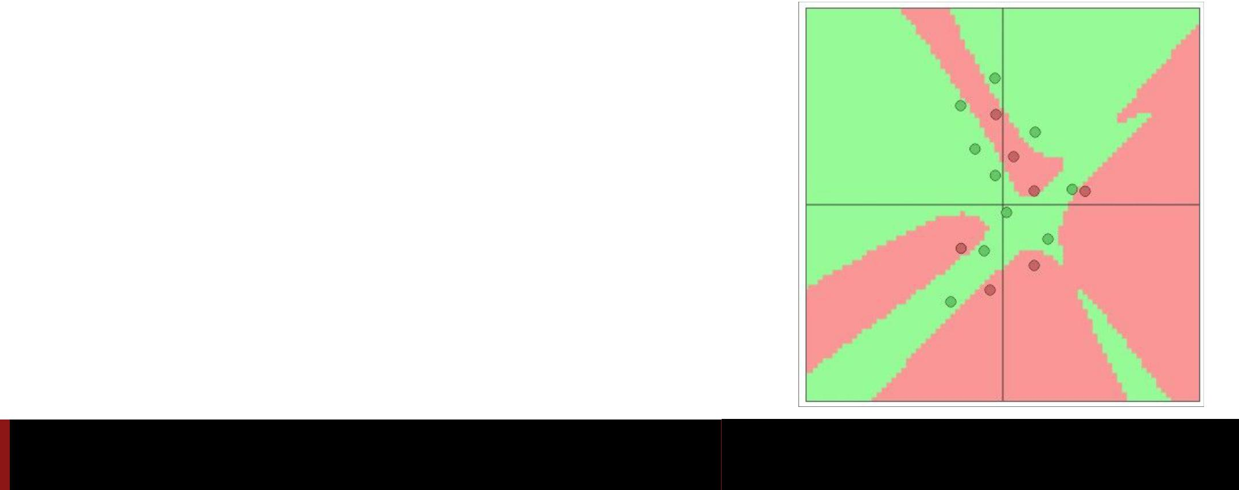

Fei-Fei Li & Andrej Karpathy & Justin Johnson Lecture 9 67 3 Feb 2016

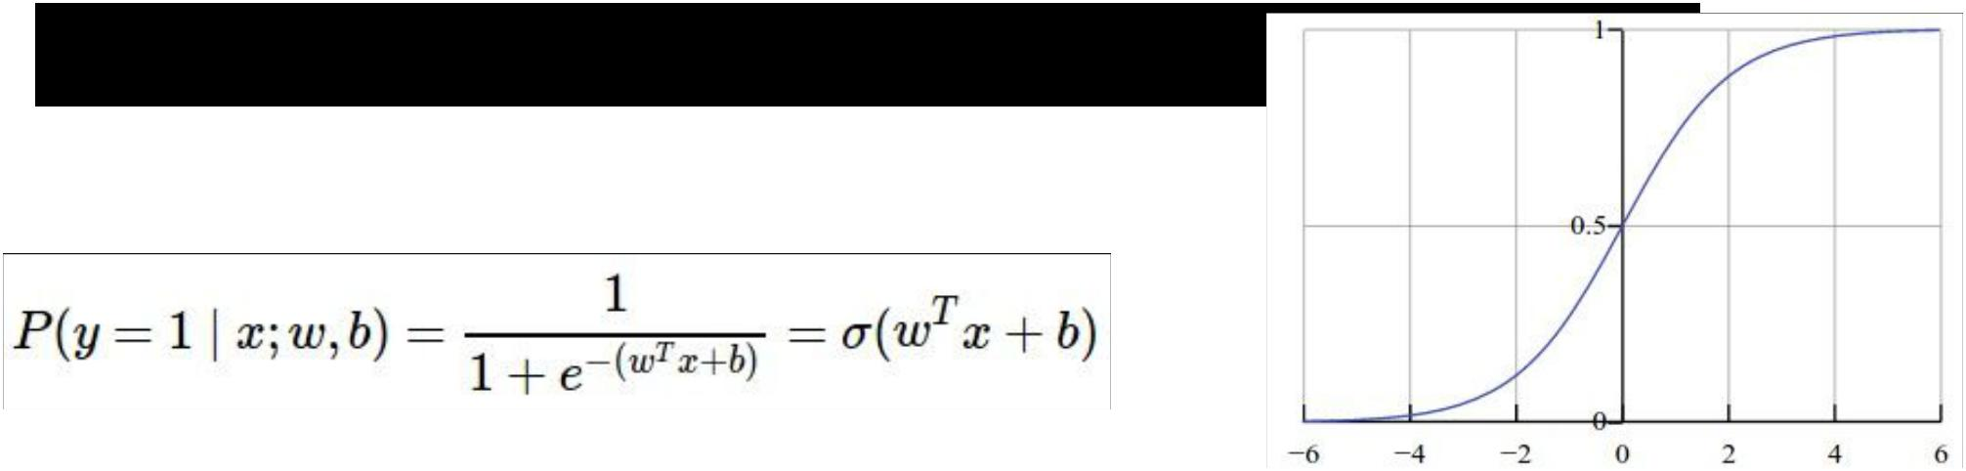Lets fool a binary linear classifier:

(logistic regression)

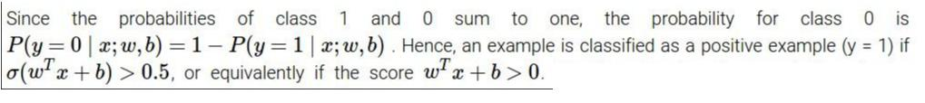

Fei-Fei Li & Andrej Karpathy & Justin Johnson Lecture 9 68 3 Feb 2016

Lets fool a binary linear classifier:

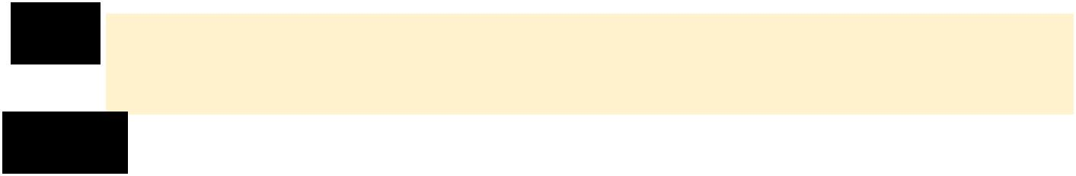

|  |  |  |  |  |  |  |  |  |  |  |  |
| --- | --- | --- | --- | --- | --- | --- | --- | --- | --- | --- | --- |
| x | 2 | -1 | 3 | -2 | 2 | 2 | 1 | -4 | 5 | 1 |  |
| w |  |  |  |  |  |  |  |  |  |  |  |
| 1 | -1 | 1 | -1 | 1 | -1 | 1 | 1 | -1 | 1 |  |
|  |  |  |  |  |  |  |  |  |  |  |
|  |  |  |  |  |  |  |  |  |  |  |  |



input example



weights

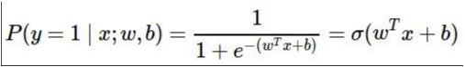

Fei-Fei Li & Andrej Karpathy & Justin Johnson Lecture 9 69 3 Feb 2016

Lets fool a binary linear classifier:



|  |  |  |  |  |  |  |  |  |  |  |  |
| --- | --- | --- | --- | --- | --- | --- | --- | --- | --- | --- | --- |
| x | 2 | -1 | 3 | -2 | 2 | 2 | 1 | -4 | 5 | 1 |  |
| w |  |  |  |  |  |  |  |  |  |  |  |
| 1 | -1 | 1 | -1 | 1 | -1 | 1 | 1 | -1 | 1 |  |
|  |  |  |  |  |  |  |  |  |  |  |
|  |  |  |  |  |  |  |  |  |  |  |  |



class 1 score = dot product:

= -2 + 1 + 3 + 2 + 2 - 2 + 1 - 4 - 5 + 1 = -3

=> probability of class 1 is 1/(1+e^(-(-3))) = 0.0474

i.e. the classifier is **95%** certain that this is class 0 example.



input example



weights



Fei-Fei Li & Andrej Karpathy & Justin Johnson Lecture 9 70 3 Feb 2016

Lets fool a binary linear classifier:



|  |  |  |  |  |  |  |  |  |  |  |  |
| --- | --- | --- | --- | --- | --- | --- | --- | --- | --- | --- | --- |
| x | 2 | -1 | 3 | -2 | 2 | 2 | 1 | -4 | 5 | 1 |  |
| w |  |  |  |  |  |  |  |  |  |  |  |
| 1 | -1 | 1 | -1 | 1 | -1 | 1 | 1 | -1 | 1 |  |
|  |  |  |  |  |  |  |  |  |  |  |
|  |  |  |  |  |  |  |  |  |  |  |  |
| adversarial x | ? | ? | ? | ? | ? | ? | ? | ? | ? | ? |  |
|  |  |  |  |  |  |  |  |  |  |  |  |



class 1 score = dot product:

= -2 + 1 + 3 + 2 + 2 - 2 + 1 - 4 - 5 + 1 = -3

=> probability of class 1 is 1/(1+e^(-(-3))) = 0.0474

i.e. the classifier is **95%** certain that this is class 0 example.



input example



weights

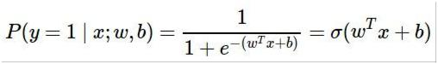

Fei-Fei Li & Andrej Karpathy & Justin Johnson Lecture 9 71 3 Feb 2016



Lets fool a binary linear classifier:

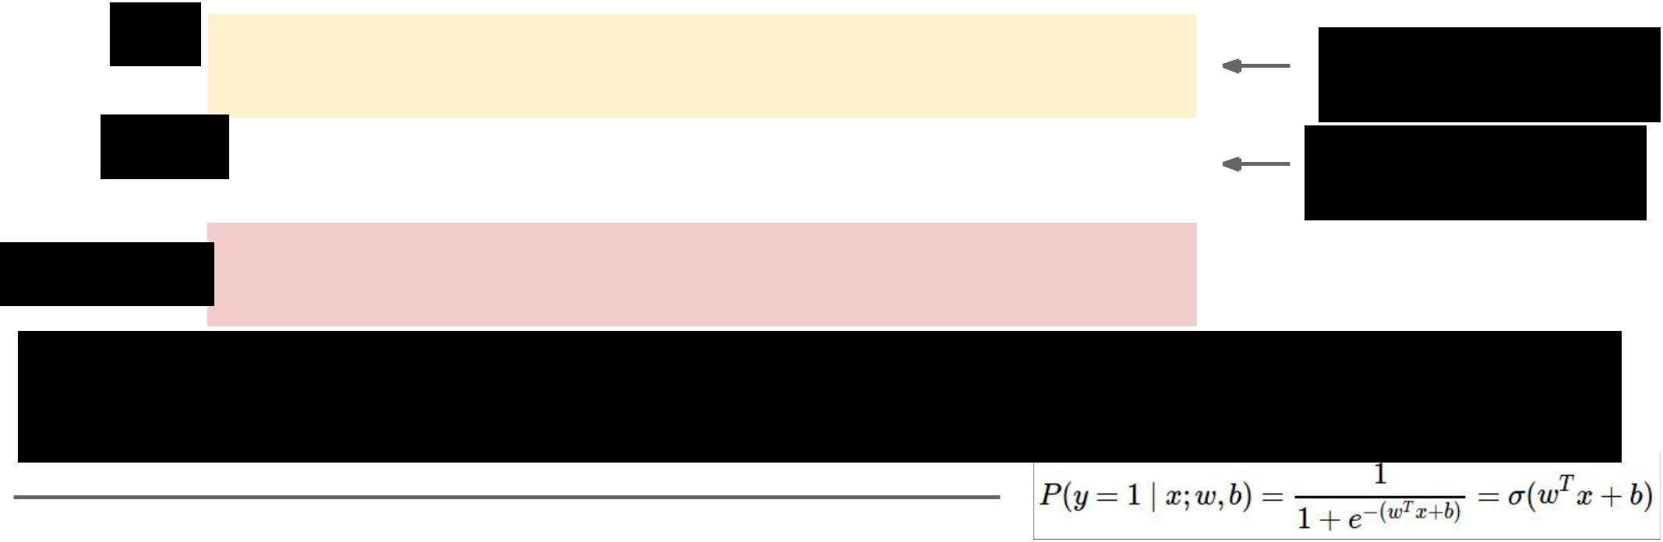

|  |  |  |  |  |  |  |  |  |  |  |  |
| --- | --- | --- | --- | --- | --- | --- | --- | --- | --- | --- | --- |
| x | 2 | -1 | 3 | -2 | 2 | 2 | 1 | -4 | 5 | 1 |  |
| w |  |  |  |  |  |  |  |  |  |  |  |
| 1 | -1 | 1 | -1 | 1 | -1 | 1 | 1 | -1 | 1 |  |
|  |  |  |  |  |  |  |  |  |  |  |
|  |  |  |  |  |  |  |  |  |  |  |  |
| adversarial x | 1.5 | -1.5 | 3.5 | -2.5 | 2.5 | 1.5 | 1.5 | -3.5 | 4.5 | 1.5 |  |
|  |  |  |  |  |  |  |  |  |  |  |  |



input example

weights

class 1 score before:

-2 + 1 + 3 + 2 + 2 - 2 + 1 - 4 - 5 + 1 = -3

=> probability of class 1 is 1/(1+e^(-(-3))) = 0.0474



-1.5+1.5+3.5+2.5+2.5-1.5+1.5-3.5-4.5+1.5 = 2

=> probability of class 1 is now 1/(1+e^(-(2))) = 0.88

**i.e. we improved the class 1 probability from 5% to 88%**



|  |  |  |
| --- | --- | --- |
| Fei-Fei Li & Andrej Karpathy & Justin Johnson | Lecture 9 72 | 3 Feb 2016 |
|  |  |  |



Lets fool a binary linear classifier:

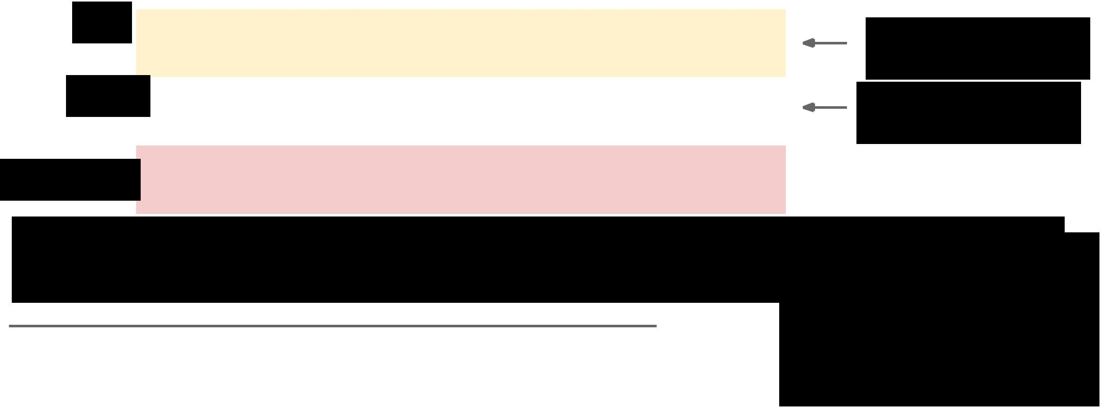

|  |  |  |  |  |  |  |  |  |  |  |  |
| --- | --- | --- | --- | --- | --- | --- | --- | --- | --- | --- | --- |
| x | 2 | -1 | 3 | -2 | 2 | 2 | 1 | -4 | 5 | 1 |  |
| w |  |  |  |  |  |  |  |  |  |  |  |
| 1 | -1 | 1 | -1 | 1 | -1 | 1 | 1 | -1 | 1 |  |
|  |  |  |  |  |  |  |  |  |  |  |
|  |  |  |  |  |  |  |  |  |  |  |  |
| adversarial x | 1.5 | -1.5 | 3.5 | -2.5 | 2.5 | 1.5 | 1.5 | -3.5 | 4.5 | 1.5 |  |
|  |  |  |  |  |  |  |  |  |  |  |  |



input example

weights

class 1 score before:

-2 + 1 + 3 + 2 + 2 - 2 + 1 - 4 - 5 + 1 = -3

=> probability of class 1 is 1/(1+e^(-(-3))) = 0.0474



-1.5+1.5+3.5+2.5+2.5-1.5+1.5-3.5-4.5+1.5 = 2

=> probability of class 1 is now 1/(1+e^(-(2))) = 0.88

**i.e. we improved the class 1 probability from 5% to 88%**



image has 150,528.

(It’s significantly easier with more numbers, need smaller nudge for each)

|  |  |  |
| --- | --- | --- |
| Fei-Fei Li & Andrej Karpathy & Justin Johnson | Lecture 9 73 | 3 Feb 2016 |
|  |  |  |

Blog post: Breaking Linear Classifiers on ImageNet



Recall CIFAR-10 linear classifiers:

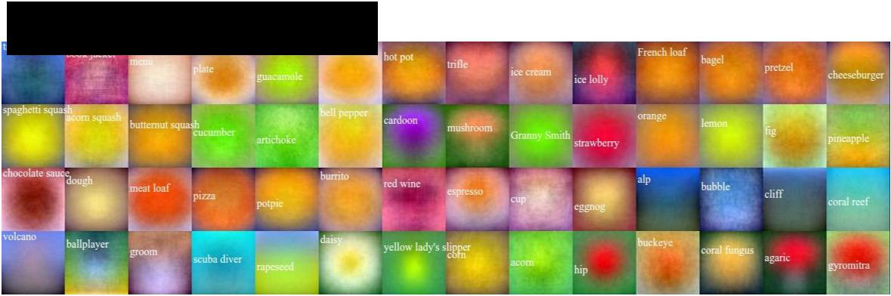

ImageNet classifiers:



Fei-Fei Li & Andrej Karpathy & Justin Johnson Lecture 9 74 3 Feb 2016



mix in a tiny bit of

Goldfish classifier weights

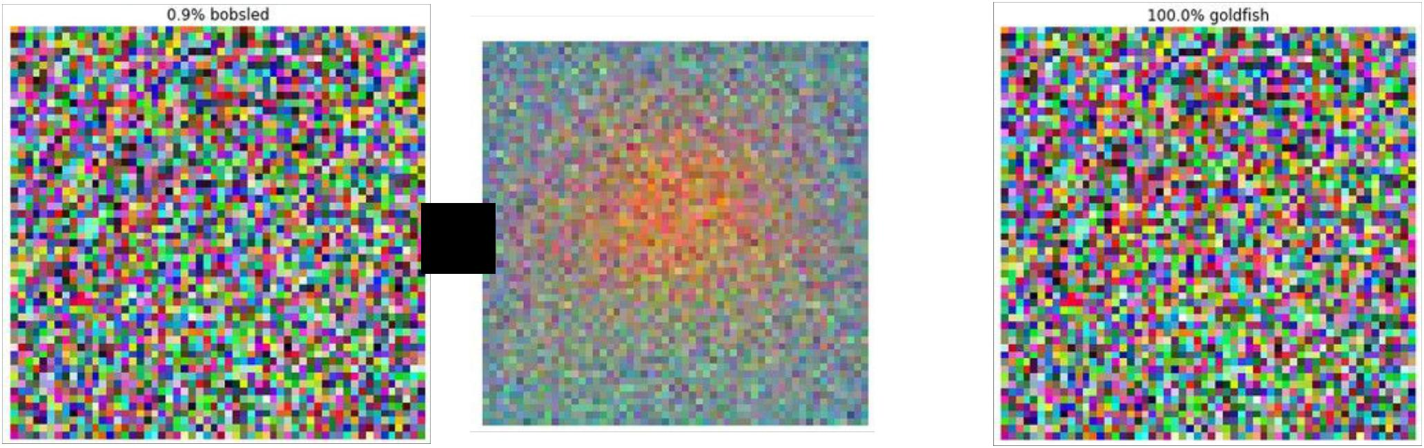

+ =

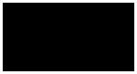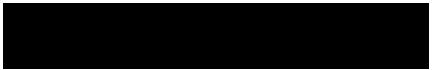

**100% Goldfish**



|  |  |  |
| --- | --- | --- |
| Fei-Fei Li & Andrej Karpathy & Justin Johnson | Lecture 9 75 | 3 Feb 2016 |
|  |  |  |

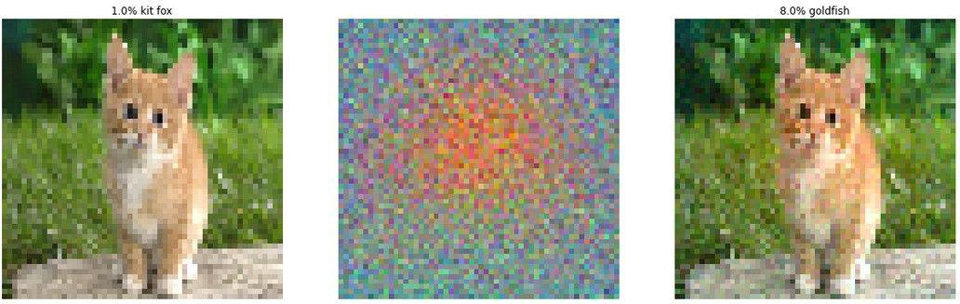

|  |  |  |
| --- | --- | --- |
| Fei-Fei Li & Andrej Karpathy & Justin Johnson | Lecture 9 76 | 3 Feb 2016 |
|  |  |  |

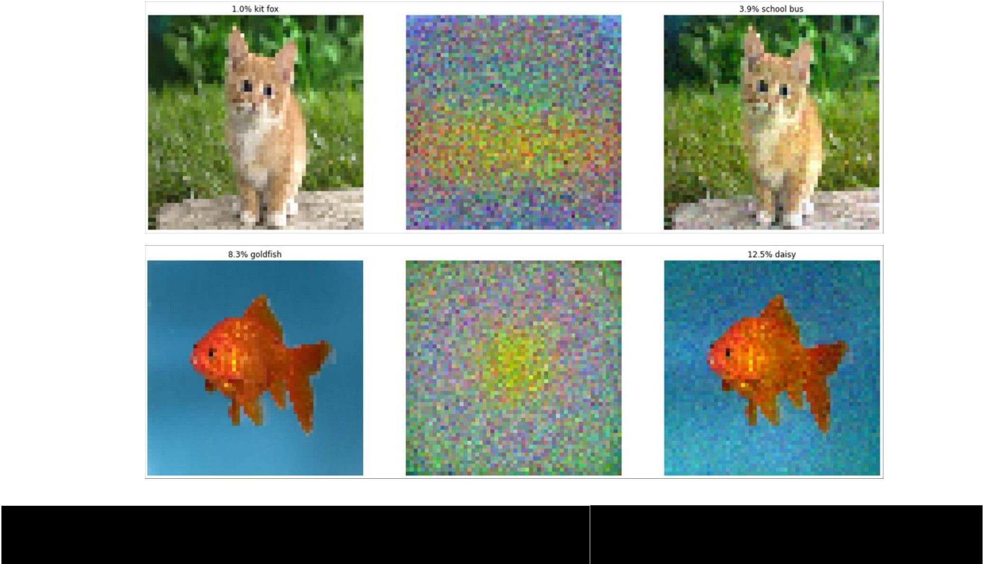

|  |  |  |
| --- | --- | --- |
| Fei-Fei Li & Andrej Karpathy & Justin Johnson | Lecture 9 77 | 3 Feb 2016 |
|  |  |  |

*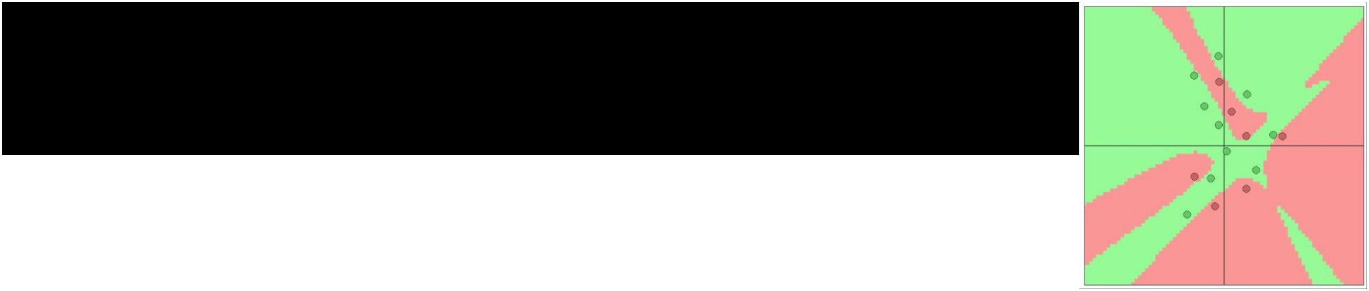EXPLAINING AND HARNESSING ADVERSARIAL EXAMPLES [Goodfellow, Shlens & Szegedy, 2014]*

“primary cause of neural networks’ vulnerability to adversarial perturbation is their **linear nature**“

(and very high-dimensional, sparsely-populated input spaces)

In particular, this is not a problem with Deep Learning, and has little to do with ConvNets specifically. Same issue would come up with Neural Nets in any other modalities.



Fei-Fei Li & Andrej Karpathy & Justin Johnson Lecture 9 78 3 Feb 2016

Summary

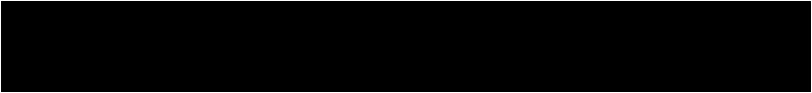

Backpropping to the image is powerful. It can be used for:

* **Understanding** (e.g. visualize optimal stimuli for arbitrary neurons)
* **Segmenting** objects in the image (kind of)
* **Inverting** codes and introducing privacy concerns
* **Fun** (NeuralStyle/DeepDream)
* **Confusion and chaos** (Adversarial examples)



Fei-Fei Li & Andrej Karpathy & Justin Johnson Lecture 9 79 3 Feb 2016

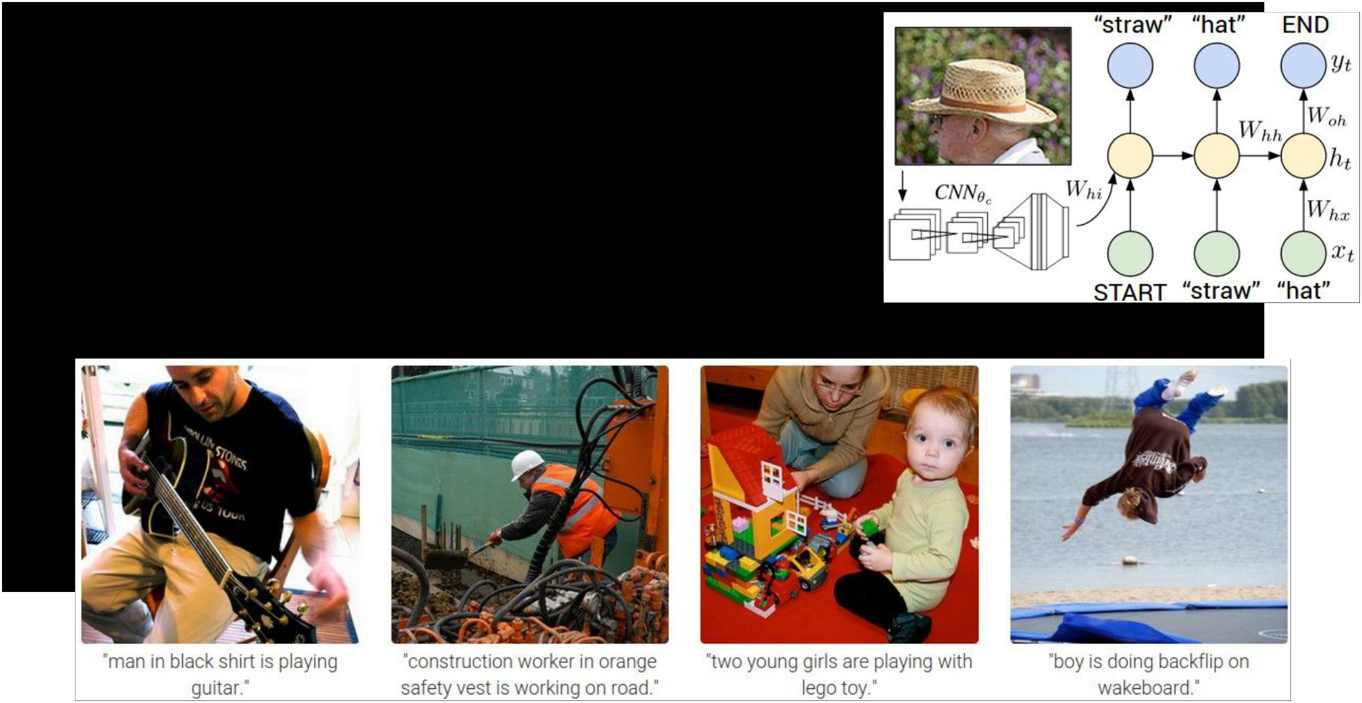Next lecture:

Image Captioning Recurrent Neural Networks RNN Language Models



Fei-Fei Li & Andrej Karpathy & Justin Johnson Lecture 9 80 3 Feb 2016

W1 ReLU W2 ReLU

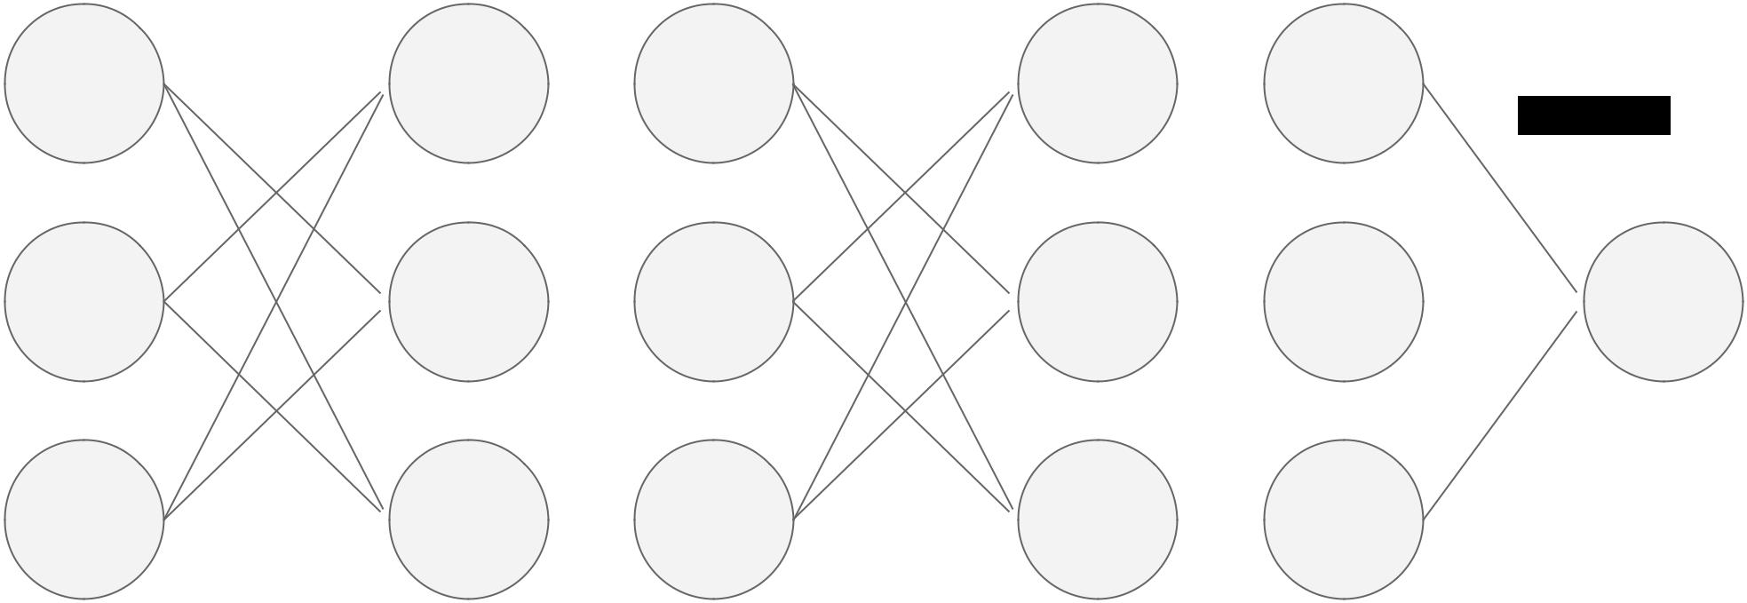

5  2  2  4  4



W3

-2 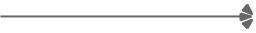 3  3  -2  0 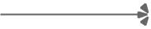 5



1  -2  0  -3  0



Fei-Fei Li & Andrej Karpathy & Justin Johnson Lecture 9 81 3 Feb 2016

**In backprop**: all +ve and -ve paths of influence through the graph interfere

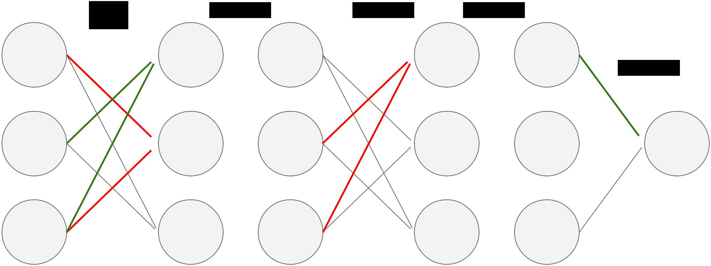

W1 ReLU W2 ReLU

5  2  2  4  4



W3

-2 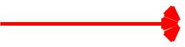 3  3  -2  0 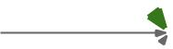 5



*  -2  0  -3  0 positive gradient, negative gradient, zero gradient



Fei-Fei Li & Andrej Karpathy & Justin Johnson Lecture 9 82 3 Feb 2016

**In guided backprop**: cancel out -ve paths of influence at each step(i.e. we only keep positive paths of influence)

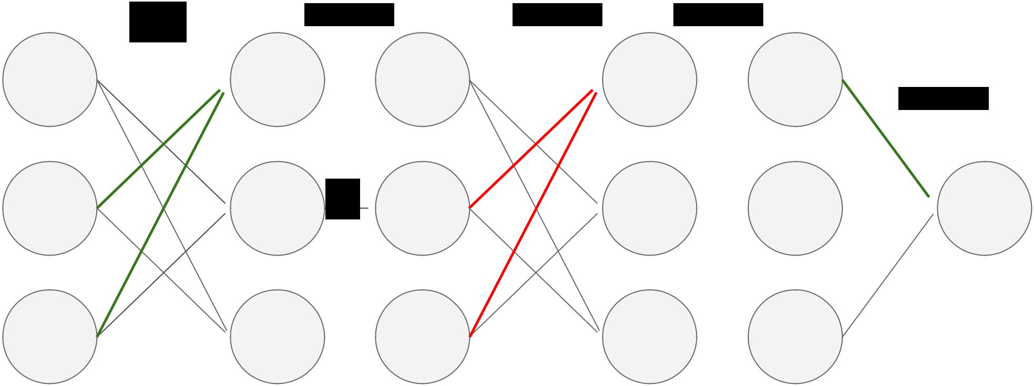

W1 ReLU W2 ReLU

5  2  2  4  4



W3

-2 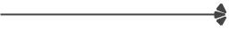 3 **X**  3  -2  0  5



*  -2  0  -3  0 positive gradient, negative gradient, zero gradient



Fei-Fei Li & Andrej Karpathy & Justin Johnson Lecture 9 83 3 Feb 2016